
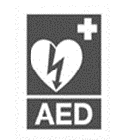
h
LISTOWEL PARISH NEWSLETTER
9th August 2026
PRIEST ON DUTY this Sunday, Fr. Keane, 09872844649

Declan Canon O’Connor P.P. V.F. - Parish Office (Mon, Tues, Thur, & Fri 10am – 1pm & 2pm – 5pm & Wed. 10am. to 1pm. closed to the public in the afternoon) 068-21188.Email: listowel@dioceseofkerry.ie. www.listowelparish.com to stream masses, forms & info. Notices for Newsletter in by 2.00pm on Thursdays. Booking of Masses: All mass intentions, must be booked at least a week before because the newsletter is a week ahead. After hours emergency number 0870908949. Baptisms are twice a month on Saturday’s only at 4pm. contact the parish office for dates.
Funerals take place on weekdays at 11.30am. Baptisms Saturday’s at 4pm.

d

MASSES THIS WEEK 9th - 16th August

Sat 8th | Anne McCarthy, Ashgrove, Months Mind /  Michael O Connor, Forge Road, Greenville, 1st Anniversary /  Miriam O Brien, College Lawn /  Peggy Hickey, & Family, Ballybunion Road /  Lily Hennessy, Killocrim | Vigil  6.15pm
Sun 9th | Sr. Francis O Sullivan | 9.00am
Sun 9th | Bill O Sullivan, Coilbee /  Pats Carmody, Meen /  Michael Carmody, Ballyduhig /  Thomas Leahy, UK & Listowel & Martin & Bridie Regan Ballyheigue | 11.30am
Mon 10th | Funeral Mass – Nora Sheahan, Greenville | 10:30am
Tues 11th | Micheal Quilter, Ballyduff | 10:30am
Wed 12th | Mass of thanksgiving / John Kelly, Lyre, Special Intention, Private Intention & Thanksgiving Mass Intention | 10:30am
Thurs 13th | Special Intention | 10:30am
Fri 14th | Rose Fitzmaurice, Charles St | 10.30am
Fri 14th | Peter Moloney & Deceased Family, Charles St. | 6.15pm
Sat 15th | Michael & Betty Quille, Church St. /  Denny, Madeline & Joe Mulvihill, Clieveragh | 10.30am
Sat 15th | Dan O Sullivan, Leitrim West, Moyvane, Months Mind /  Betty Griffin, Ballygologue Pk. /  Kathleen, Julia & Jeremiah Duggan /  Thomas & Annie O Connor & Deceased Family, Asdee /  Mary Reidy, Killocrim /  Johnny Nolan & Maurice Hickey & Deceased Family, Ballybunion Rd. / Kay O Connor, Craughatoosane /  Deceased Members of the Galvin Family & John & Mary Brennan, Dirha West | Vigil  6.00pm
Sun 16th | Dermott & Catherine Kennelly, Tarbert | 9.00am
Sun 16th | Jackie & Robert Twomey, Ballahadigue | 11:30am

RECENT DEATHS & FUNERALS

Colin Grimes, Feale Drive. / Bridie Gorman, Knockane. / Nora Sheahan, Greenville.

REMINDER BOOKING OF MASSES All mass intentions must be booked in during office hours in the parish office at least a week in advance with no more than four names.
068-21188 / listowel@dioceseofkerry.ie

SATURDAY NEXT (AUGUST 15TH ) WE CELEBRATE THE FEAST OF THE ASSUMPTION.
It is a Holy Day of obligation, and we will celebrate a Vigil Mass here in Listowel on Friday evening at 6.15 p.m. and Mass on Saturday morning is at 10.30 a.m.

The Meaning of the Assumption: A Unique Privilege for the Mother of God.

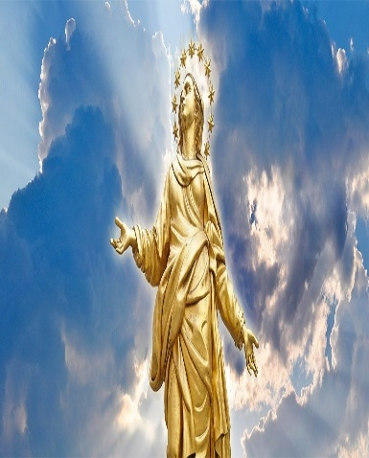
The Assumption is not simply a celebration of Mary’s holiness, but also a profound recognition of her unique role in salvation history. Because she was preserved from original sin from the moment of her conception, it is fitting that she would not undergo bodily corruption after death. The Church teaches that, at the end of her earthly life, the Blessed Virgin Mary was taken up into Heaven — not by her own power, but through the grace and will of God. A Sign of What Awaits the Faithful the Assumption is often called a “first fruit” of what all faithful hope to experience at the resurrection of the body. It serves as a powerful sign of the destiny God intends for each of us: life in His presence, not only in spirit, but also in glorified body. Mary’s Assumption reminds us that death is not the end, but a doorway to divine fulfilment. On this day, Catholics attend Mass and reflect on the mystery of Mary’s passage into Heaven. In a world often filled with uncertainty, the Assumption offers a message of hope. Mary’s life — marked by humility, obedience, and unwavering trust in God — culminates in her entrance into eternal glory. Mary continues to intercede for us. Her Assumption is not a departure from our lives, but a closer bond with humanity. From her place in Heaven, she watches over the Church, guiding us with maternal care and leading us ever closer to her Son, Jesus Christ.

REVIVAL FESTIVAL 2026 – THE SQUARE NEXT WEEKEND - Saturday evening next - 15th August. The Square will be closed off for parking. Please note, because of traffic & restricted parking with the Concert beginning at 7.00 p.m. the Vigil Mass on Saturday 15th August, will take place at the earlier time of 6pm.

