

h
LISTOWEL PARISH NEWSLETTER
5th Sunday of Easter
PRIEST ON DUTY this Sunday, Fr. Pat Crean-Lynch, 0872200114

Declan Canon O’Connor P.P. V.F. - Parish Office (Mon, Tues, Thur, & Fri 10am – 1pm & 2pm – 5pm & Wed. 10am. to 1pm. closed to the public in the afternoon) 068-21188.Email: listowel@dioceseofkerry.ie. www.listowelparish.com to stream masses, forms & info. Notices for Newsletter in by 2.00pm on Thursdays. Booking of Masses: All mass intentions, must be booked at least a week before because the newsletter is a week ahead. After hours emergency number 0870908949.
Funerals take place on weekdays at 11.30am. Baptisms Saturday’s at 4pm.

d

MASSES THIS WEEK 10th – 17th May
Sat 9th | Anthony Browne, Ballygologue Pk. /  John & Peg O’Connell, David Roche, O’Connell’s Ave. &  Slyvester O Halloran, London /  Martin & Peggy Mulvihill & dec. family, Asdee /  Eoin O Neill, Ballygologue Rd /  Anne Prendiville, Moyvane | Vigil  6.15pm
Sun 10th | Joe Flavin, Cork & Knockane /  Maurice Hayes, Tanavalla & Fr. Rodger Duggan MSC., Cork & Australia | 9.00am
Sun 10th | Sean Kennelly, O’Connell’s Ave., months mind /  Helen Galvin, The Lodge, months mind /  Eamon Muprhy, Behins /  Danny Barrett & dec. family, Ballygologue pk. & Clieveragh /  Mary Enright, Ballygologue Pk. /  Tom O Connell, Ballygrennan / Kevin McCarron, Gurtinard, bir. rem. | 11.30am
Mon 11th | Kathleen & James Keane-Stack, Lower William St. /  Mass of thanksgiving | 10:30am
Tues 12th | Cyril Puttock, Charles St., wedding ann. rem. | 10:30am
Wed 13th | Special Intention | 10:30am
Thurs 14th | Special Intention | 10:30am
Fri 15th | Jeremiah & Bridie O Driscoll, Dirha West | 10.30am
Sat 16th | Memorial Mass – Victor Broderick, Dublin late of William St. | 10.30am
Sat 16th | Danny Shine, Ballygologue Pk., months mind /  Brenda Woulfe, Ferndene, months mind /  Norma Harrington, Feale Dr., months mind /  Patsy Barry, Dirha Cottage months mind & Jame & Paddy Barry /  John Guiney Sen., Charles St. / John Moran, Billerough /  Tom O Connor, Ballygologue Pk., bir. rem. /  Elie Lawlor, Bridge Rd. /  Nora Lane & dec. family, Beenanaspig | Vigil  6.15pm
Sun 17th | Margaret Sheehy, Ballygologue Rd. & Duagh, 1st ann. /  Peg Boland, Market St. | 9.00am
Sun 17th | Liam O Driscoll, Feale Dr. / Margaret Thomson, Perth & Coolaclarig /  Billy McElligott, Coolaclarig / Tom & Hannah Barrett, Greenville /  Tom O Connor, Bunagara / Philomena & Willie Walsh, Dirha West /  Thomas Collins, Ballymacjordan, Abbeyfeale | 11:30am

ANNIVERSARY REMEMBRANCE Bridie Halpin, Greenville.
KERRY DIOCESAN COLLECTION - EDUCATION OF CLERGY will be taken up at all masses this weekend after communion.

CONGRATULATIONS TO THE CHILDREN from Killocrim National School, Scoil Réalta na Madine, An Gael Scoil & the Presentation Primary School on receiving the sacrament of Communion this weekend - Saturday 9th May. Well done to the pupils, teachers & families.
Rosary for the month of may O’Connell’s Ave Grotto every Sunday in at 6pm. Finuge Grotto every Tuesday at 8pm. Killocrim Grotto every Friday evening at 8pm. All welcome.
LISTOWEL ANNUAL CEMETERY MASSES St. Michael’s Cemetery, Tuesday 23rd June, St. John Paul II Cemetery, Wednesday 24th June and Finuge Thursday 25th June all masses are at 8pm.
REMINDER BOOKING OF MASSES All mass intentions must be booked in the parish office at least a week in advance with no more than four names. 068-21188 / listowel@dioceseofkerry.ie
ST. JOHN’S CEMETERY BALLYBUNION annual cemetery mass Friday 5th June at 7pm.

Well done the Listowel Parish Youth Group that did a Lenten activity of faith with their families over the Easter period Visio Divina (painting by numbers) what beautiful paintings. Well done to all involved
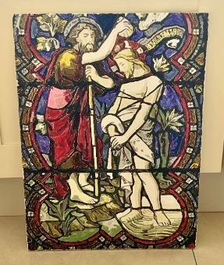
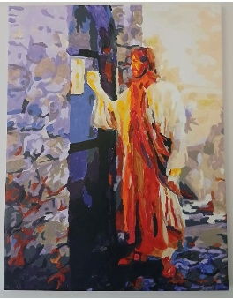
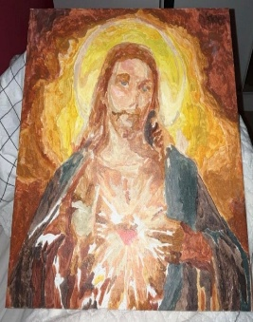
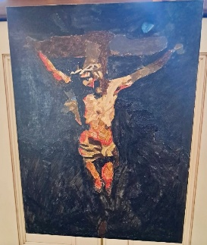


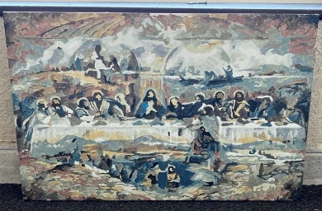
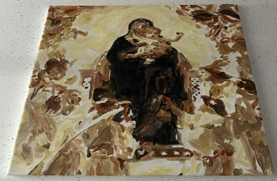

COMMUNITY NOTICES

COMHALTAS invite for anyone who had any dealings with Comhaltas over the years. The unveiling of a plaque on Thursday 14th May at 7.00pm. at the Listowel Arms Hotel. Refreshments afterwards All welcome.
LOUGH DERG - 4 day Pilgrimage 2026 Leaves Cork Friday 5th June at 9am. Returning Monday 8th June. Booking & Information Ph. Paddy 021 4502572.
‘ECHOES OF SUMMER’ A night of Song and Poetry with The North Kerry Community Choir with Musical Director Mary Culloty O’ Sullivan plus special guests Wednesday May 20th 7.30pm in the Listowel Arms Hotel. Donations for The Kerry Hospice Foundation upon entry .

