Your Wedding in
St. Mary’s Church, Listowel

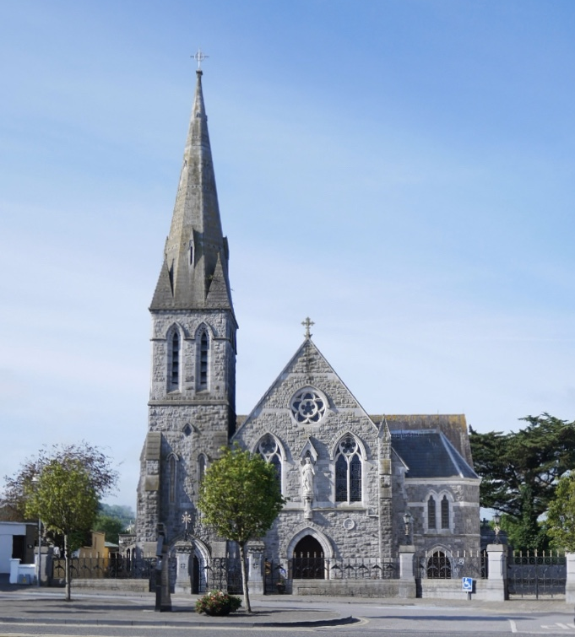

Congratulations to you on your engagement! We pray God’s blessing on you in this time of preparation and ask God’s guidance for you in your married life. Getting married in our Church means that you will be celebrating the Sacrament of Marriage, one of the seven sacraments in our Church, a time to be enriched with God’s grace.

We are happy to be a part of your Wedding preparations and hope the following information will be helpful to you.

IN PLANNING TO GET MARRIED IN THE CATHOLIC CHURCH, THE COUPLE MUST BE:
- At least one of the couple is Catholic
- Both are adults, 18 years or older
- Be one male and one female
- Both must be free to marry in the Church (i.e. never have celebrated a religious or civil marriage, or if one has been married, they are either widowed or annulled). If you have questions about this, contact a priest immediately.
- Both understand and accept that marriage is a lifelong loving commitment, with faithfulness to each other, and are open to children in their marriage.
ARRANGING A DATE & TIME FOR THE CHURCH AND BOOKING THE PRIEST: All details are on www.listowelparish.com To make the arrangements for the date & time of your wedding in our parish, you will need to contact us at the Listowel Parish Office (068 21188) during office hours or email: listowel@dioceseofkerry.ie You will then be asked to fill out a booking form and to give your offering to the Church within 2 weeks of booking, so as to confirm your commitment to that date, and to be sure of your booking. If we haven’t heard from you by the 2 weeks, we will presume you have made other arrangements and we will then be able to offer that date and time to others.
REGARDING THE PRIEST TO CELEBRATE YOUR WEDDING: The Parish Priest will be delighted to celebrate the weddings of all our parishioners (subject to availability), so make direct contact with him through the Parish Office or personally at deckyoc@gmail.com You are also welcome to make arrangements for getting your own a priest (e.g. a priest who is a family member, a friend or a priest from your own parish). For those from outside our parish, we will also do everything possible to facilitate them subject to availability or we may be able to suggest someone.
YOUR OFFERING FOR THE WEDDING: We are most grateful for your generosity and support to the parish, & to all who have gifted us with such a beautiful church. As a guide, the following may be of help.
- Suggested offering for the church is €200.00 which includes €50.00 for the Sacristan who will be with you on the day to make the preparations for the ceremony. You may pay it directly at the Parish Office at the time of the booking or pay online at IBAN IE46AIBK93543323179025 and put reference with your ‘name followed by wedding’.
- Please note that this does not include the offering for the priest who will be celebrating your wedding Mass. You can make your own offering to him yourself, aware of his time with you in planning your wedding, assisting with the pre-marriage papers, the wedding practice, and on the wedding day itself. It is an offering and we appreciate and respect the different circumstances of each individual.
CHURCH AND CIVIL REQUIREMENTS FOR YOUR WEDDING CEREMONY: In celebrating your wedding, you will be celebrating a Catholic ceremony that usually has civil recognition. For the civil recognition, you must fulfil the legislation of the Irish State. It is your responsibility to contact the Civil Registration Office 064-6632251, Killarney, Co. Kerry / www.civilregistrationservice.ie ) and give at least 3 months’ notice to the State to fulfil the legal requirements - If you are living outside the State you may need to allow extra time for this. When the registration is complete, you will be issued with a Marriage Registration Form (MRF). This is the legal form that you will keep in your possession and it will be signed on the day of your wedding by you, your witnesses, and by the priest. It is advisable for you to nominate someone who will take responsibility of this MRF, a legal document, taking it from the Church after signing, holding it for you in safekeeping before you return to the Civil Registration Office within a month.
CHURCH REQUIREMENTS FOR YOUR WEDDING: PRE-MARRIAGE COURSE: Because your wedding is a special and important moment in your life, the Church / Diocese wishes to ensure that you have the preparation for you as a couple to reflect as you journey forward. With this in mind the Diocese requires you to undertake a Pre-Marriage Course. Nationally, the diocesan approved pre-marriage courses are facilitated by Accord: www.accord.ie Tralee Centre 066-7122280 or Killarney Centre 064 6632644. Contact them to organise your attendance on the course that best suits you. Ideally you should do this at least 6 months before your wedding to get a booking and avoiding all the pressures that a wedding brings.
PRE-NUPTIAL PAPERS: The Church wishes to ensure that everything is in order for your wedding. Each of you will need to complete your Pre-Marriage Papers (Pre-nuptial Enquiry Forms) with the priest of the parish where you are living. He will then forward them to us. Ideally this should be done at least 2 months before the wedding. If you are living outside the Parish or living in another country or is a mixed marriage you might need to allow extra time for this. To complete the pre-marriage papers, you will include your baptismal certificate, your confirmation certificate these certs have to be new 6 months or less from your wedding date from your Parish Register and your letters to testify your freedom to marry in the Church.
ORGANIZING THE WEDDING CEREMONY - PLANNING THE READINGS, PRAYERS ETC.:
The ceremony is prepared with the priest who will celebrate your wedding, and he will be able to guide you in your planning. You will choose scripture wedding readings, Prayers of the Faithful (bidding prayers), and decide on the recommended vows you will be exchanging. You should also receive resources at your pre-marriage course.
CHURCH MUSIC: You should choose Church hymns or liturgical music that is suitable to the prayer of the wedding ceremony. Secular songs are generally not appropriate for the Mass and Sacrament of Marriage. Please convey this to the singers/musicians, ask them for their suggestions from the rich store of liturgical hymns and music, and talk to your priest when confirming your music choice. Ask the singers/musicians to contact the Parish Sacristan before the day of the wedding to determine their location during the wedding ceremony.
FLOWERS, CANDLES ETC.: St. Mary’s Church has fine architectural beauty so we ask the following:
- Flowers should only be used sparingly. Artificial flowers and arches and Carpet should not be used.
- Because of safety concerns, naked candles are not allowed outside the sanctuary. Battery operated candles are fine.
- No rice or confetti may be scattered in the Church or on the grounds.
PHOTOGRAPHERS/ VIDEO TECHNICIANS: are welcome, provided that they are suitably dressed, remain outside the sanctuary during the Mass, and remember to protect the prayerfulness of the ceremony by not causing distraction. Please convey this to those you are engaging for this, either family members or professionals.
WEDDING PRACTICE: In booking your wedding practice, please arrange this with the priest celebrating your wedding, and arrange it too with the Parish Office for a suitable time for all.
PUNCTUALITY: We draw your attention to the fact that as you are planning your own wedding day, the Church is also available for other Masses and ceremonies. We ask for you to make every effort in being punctual for your wedding practice and especially for the Wedding Ceremony itself, so that all may go calm and smoothly for yourself and for all others.
FINAL WORD: We aim to make your wedding day the happiest day of your life – as you ask God to seal your union in the sacrament of marriage. In preparation, you should create space for your own prayer and reflection, asking God to guide you as a couple. God Bless.

LISTOWEL PARISH OFFICE, Bridge Road, Listowel, Co. Kerry. Tel. (00353) 68 21188
Web Page: www.listowelparish.com email: listowel@dioceseofkerry.ie
Parish Office Hours: Mon. to Fri. 10 a.m. – 1p.m. & 2p.m. - 5p.m.

