St. Mary’s Church Listowel
Holy Week PROGRAMME

Listowel Parish Liturgy Group, invite you to enter into the spirit of Holy Week by joining us for the Holy Week Ceremonies which celebrate the anniversaries of the events of the Passion, Death and Resurrection of Our Lord taking place at the following times:

Palm Sunday Blessings
of Palms (Vigil Mass 6.15pm. Saturday Eve & 9am. & 11.30am. on Sunday morning)

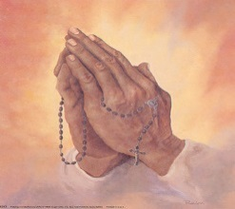
Monday 30th March mass at 10.30 a.m. Penitential Service at 8pm. including individual Confessions with a number of priests present. We encourage as many as possible to avail of the opportunity to have their Easter Confession.


Tuesday 31st March Mass at 10.30 a.m. CHRISM MASS at 7pm. St. Mary’s Cathedral, Killarney. Bishop Ray has invited all parishioners to this Mass at which the priests of the Diocese renew their priestly vows. Also all the Oils used for the various sacraments for the coming year are blessed. There will be refreshments after the Mass in St. Brendan’s College refectory. Everyone is welcome.

Spy Wednesday 1st April
Mass at 10.30 a.m.

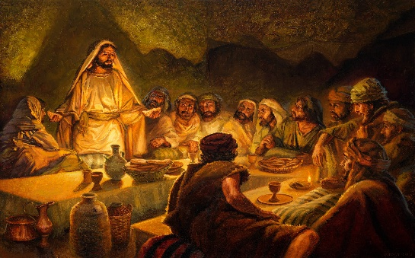
Holy Thursday 2nd April Morning Prayer at 10.30 a.m. followed by Confessions. Mass of the Lord’s Supper 8.pm. Church will remain open until 10pm. for prayer. You are invited to spend some time with the Lord during this time. This recalls his night of prayer in the garden of Gethsemane.

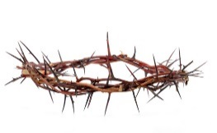
Good Friday 3rd April Morning Prayer at 10.30 a.m. followed by Confessions


The Lord’s Passion 3pm.

Stations of the Cross 8pm.

Holy Saturday 4th April Morning Prayer at 10.30 a.m. followed by Confessions

Easter Vigil 8pm.

Easter Sunday Mass 9.00 a.m. & 11.30 a.m.


