


Fr. Declan O’Connor P.P. V.F. - Parish Office (Mon – Fri 10am – 1pm & 2pm – 5pm) 068-21188.Email: listowel@dioceseofkerry.ie. www.listowelparish.com to stream masses, forms & info. Notices for Newsletter in by 2pm on Thursdays. Booking of Masses: must be booked at least a week in advance .
LISTOWEL PARISH NEWSLETTER
22nd March 2026
PRIEST ON DUTY this Sunday, Fr. Buckley, 0872409624

o++ h

MASSES THIS WEEK 22nd - 29th March
Sat 21st | John Stack, London & Charles St., months mind /  Noreen Dillon, Ennismore & Knockane, rec. dec. /  Anthony & Maire Greaney, Ballygologue Park /  Michael Shanhan, Dromin, bir. rem. /  Con, Elizabeth & Sr. Pius O Farrell & dec. fam., Church St. /  Phyllis Diggin Treacy Main St. Ballybunion & dec. members of the Diggin family | Vigil  6.15pm
Sun 22nd | Anne Powell, Dublin & Offlay /  Michael & Elizabeth Quille, Woodford | 9.00am
Sun 22nd | Fr. Teddy Molyneaux, Port Elizabeth & Woodford /  Bob Belote, Alanta, Jorda, USA, rec. dec. /  Georgina Barrett, Golf View / Denis Fitpatrick, Church St. /  Paddy & Eileen McElligott, Jack & Nora McElligott, Coolaclarig / Monica Corridan nee Chute | 11.30am
Mon 23rd | Noreen Holyoake Keys, Lartigue View  Joe Hannon, Charles St. /  Private Intention | 10:30am
Tues 24th | Neleus Leahy, Feale Drive | 10.30am
Wed 25th | Special Intention | 10.30am
Thurs 26th | Private Intention | 10.30am
Fri 27th | Special Intention | 10:30am
Sat 28th | Funeral – PJ O’Gorman, Clieveragh Road | 10.30am
Sat 28th | Tom Keane, Ballylongford, 1st ann. & dec. members of the Keane & Scanlon family /  Michael O Sullivan, Cricklewood & Tanavalla, 1st ann. /  Jim Quinlan, Aviation Dr., Bir. & ann. Rem. /  Paul Kirby, Charles St. / Dan Sullivan, Skehenerin /  Margaret Barrett & dec. members of the Lyons family, Clieveragh /  Maurice Walsh, The Square & Cahirdown /  Lilianne Curtin, Coolaclarig / Sheila Ryan, Skehenerin /  Peg Dore, O’Connell’s Ave & Lartigue Village & Gee Dore, Charles St. | Vigil  6.15pm
Sun 29th | Dan & Deb Guiney & Sr. Mary Tarrant, Gurtcreen /  Henritta Dillon, Behins | 9.00am
Sun 29th | Daniel Cantilon, Skehenerin / Kathleen O Sullivan, Old Rd., Clieveragh / Anne Wixted, Ballinruddery, bir. rem. /  Brendan & Patsy Sugrue, London, Kerry & Roscommon & Sheila Guiney, Charles St. / Patricia & Catherine (Josie) Kelly, Cahirdown | 11:30am

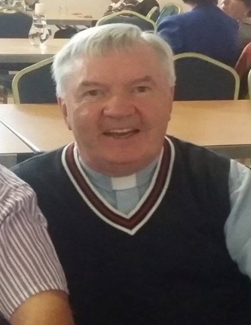
RECENT DEATH & FUNERAL ARRANGEMENTS FOR
Fr. Jack O Donnell RIP, Shanbally, Duagh. Reposing in Harnett’s Funeral Home Abbeyfeale Monday 23rd 5pm to 8pm. Requiem Mass Tuesday 24th at 12noon in St. Brigid’s Church, Duagh burial in Springmount, Duagh. He will be remembered for his gracious manner, his keen intellect and his friendly disposition. He has left a significant void to the many parishioners in Duagh / Lyre & our Listowel Pastoral Area.

ANNIVERSARY REMEMBRANCES Parick O Shaughnessy, William St. & Michael O Shaughnessy, Kentucky / David Bunyan senior, Convent St. & deceased members of the Bunyan & Lambert family / Joe Setota, New York.


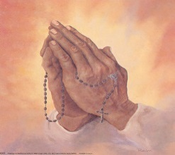
SUNDAY NEXT APRIL 29th IS PALM SUNDAY: and the beginning of Holy Week and celebrate the Passion, Death and Resurrection of Our Lord. The blessing of Palms will take place at masses this weekend. Many thanks to John Doyle, Clounmacon for providing Palms.
HOLY WEEK / EASTER CONFESSIONS Our annual Penitential Service for Holy Week with a number of Priests hearing Confessions will take place on this Monday night (30th March) at 8.00pm. We invite you to avail of the opportunity to do their Easter duty.
TROCAIRE OFFERINGS: Reminder to return your Trócaire Offering to the Church during the Holy Week. Your offering is much appreciated.
SPRING / EASTER OFFERINGS: Please return your Easter / Spring Offerings which support your priests at our Holy Saturday night Mass or on Easter Sunday morning. This is the envelope with a green stripe in your offerings box or use the loose envelope with the green stripe at the back of the church. As is the Diocesan Policy now, we will facilitate this collection by passing the Baskets around after Holy Communion at the Easter Vigil & Easter Sunday masses as a second collection. Many Thanks for your support & generosity.
LENTEN DEVOTIONS: We will pray a short Stations of the Cross after the 10.30 a.m. Mass each Friday morning during Lent.
REMINDER BOOKING OF MASSES All mass intentions must be booked at least a week in advance with no more than four names. Thanks for your co-operation.

PARISH BOX ENVELOPES 2026 For anyone that hasn’t pick up their envelope box, they are up next to the altar railing next to the sacristy door. Your name, address and box number are on the boxes.

