S T. M A R Y’ S C H U R C H L I S T O W E L

MASSES
Christmas Eve  Wednesday 24th | Maire Fealy, Courthouse Rd., Birthday Rem. /  Margaret Carmody nee Horgan, Knockroe Drive /  Michael, Pauline & Yvonne Kennedy, Limerick | 4pm
Christmas Eve  Wednesday 24th | Michael McDonnell, Co. Clare & London /  Christoper Smyth, Listowel & Kent, England, bir. rem | 6pm
Christmas Eve  Wednesday 24th | Frances McMahon, Co. Clare | 8pm
Christmas Day  Thursday 25th | People of the Parish | 9am
Christmas Day  Thursday 25th | Charlie Chute, Greenville / Sharon Moriarty, Knockroe Drive / Jim, Anne, Voureen & Nora O Sullivan, Charles St. /  Maureen Molyneaux, Bedford & London /  Kitty Curtin & dec. family, Dromin | 11:30am
Friday 26th | Michael McCarron, Gurtinard, bir rem. | 10:30am
Saturday 27th | Michael Moore, Cahirdown & Michael & Elizabeth Moore,  & Henry Scholl /Edel O Halloran, Church St. /  50th Wedding anniversary intention | 10:30am
Saturday 27th | Martin (Manie) Enright, Ballygologue Pk, 1st ann. /  Brid Quigley, Woodlawn, 1st ann. /  Maire & Joe Shaw, New Jersey & Colbert St. /  John, Ned & Paddy Fealey, Ennismore /  Joan, Hannah & Dan Walsh, Craughatoosane /  Patrick & Margaret Moloney, Ballylongford /  Maureen O Connor, Bunagara, bir. rem. /  Thomas & Annie O Connor, Asdee / Bill O Sullivan, Coilbee /  Dec. mem. Fitzgerald, Corridan & Moriarty families /  Eamon & Jacquline Roche, O’Connell’s Ave. /  Angela Kearney, Moyvane & Cahirdown | Vigil  6:15pm
Sunday 28th | John Charlie O Sullivan, Killocrim /  Bridie Sayers, Greenville /Paul McCarthy, Tanavalla /  Pat & Christy Walsh, Upper Dirha West /  Lila Stack & Eleen Stack Cotter, Charles St. & Glenoe | 9:00am
Sunday 28th | Anthony McAuliffe, Convent St. 1st ann. /  Michael O Connor, Springmount, Duagh /  Dec. mem. of the Bartishell family, Convent St. /  Molly & Jack Nolan, Aviation Dr. /  Jack & Catherine Scannell, Bunagara / John O Mahoney, Ballygrennan & Skehenerin / Tadgh Laide, Ballygologue Pk. / Elizabeth (Betty) Kennelly Ashfield | 11:30am

May the peace of Christ be with you and may you enjoy
a very Happy & Holy Christmas
THE BIRTH OF JESUS CHRIST 25TH DEC.

Thank You – ‘Míle Buíochas’
As we celebrate Christmas and bring the year 2025 to a close, I feel that I’m very privileged and indeed it is my honour to continue working with you as your Parish Priest here in Listowel. I would like to take this opportunity to thank you sincerely for the support that you give to your Parish and to me personally throughout the year. It takes a lot of people to make a Parish active and to keep it going in these challenging times. It could not happen only that we are blessed with good staff, Parish Secretary Denise and both sacristans Martina and Helen and a lot of volunteers who are dedicated to our Parish. Many of you work behind the scenes and you might feel your work sometimes goes unnoticed, but each person in their own right plays their part, and each does it so well. A special thanks to Fr. Martin, Fr. Jack, Fr. Brendan Carmody, Fr. Brendan Walsh & Fr. Anthony of our Pastoral Area.

I thank the Parish Finance Council who keeps an eye on the Parish Finances. I thank the Parish Pastoral Council and the Safeguarding Committee for their support and guidance. Thanks to the Parish Liturgy Group who co-ordinate the various ministries and liturgies. The Eucharistic Ministers / Parish Youth Group / our Readers / the Collectors & the Counting Teams who count the parish offerings, the Parish Choir, / Parish Folk Group, their members, their directors and musicians. We are blessed to have Adoration of the Blessed Sacrament weekly in our Parish. Thank you all who make it possible. We have the Padre Pio Prayer Group, Medjugorje Group & Lectica Divina Group who run their regular meetings - I’m not forgetting our Altar Servers, their parents, their mentors & their teachers for their support. You all do a great job, and your help is much appreciated.

To those who clean the church - not alone is this done for Christmas, but it is done quietly all year around. Those who donate flowers and look after both inside and outside the church and Presbytery grounds throughout the year. So many visitors remark on how well each place looks. This is a tribute to you, so take a bow. To those of you who put up our Crib and those who are available at moment’s notice to do the various maintenance jobs of the Parish throughout the year.

We are dependent on each other for friendship, support, and finance. Thank you for your generosity and kindness to your Parish and to me personally right throughout the year. I pray that God will bless and reward you and your family with all his gifts this Christmas and throughout the new year of 2026.

God Bless Fr. Declan

MASSES NEXT WEEK

Monday  29th | Bridget Quigley, Woodlawn, 1st anniversary /  Angela McKeon nee Henigan, USA & The Square /  Con, Nancy & John Keane, Church St. | 10:30am
Tues 30th | Deceased members of the Sweeney family Convent St. | 10:30am
Wed 31st | Special Intention / dec. mem. O’Connor fam., Shrone /  Camel Walsh, Ballygologue Pk. / Kitt & Pat Dowling, Bridge Rd | 10:30am
Thursday  1st | Brendan Guiney, Charles St. & John Senior Guiney, bir. rem. / Peggy O Dell Moloney & dec. family, Charles St. /  Jerry, Kathleen & Eamon Dunlea, Ballylongford /  Anne Marie O Sullivan, Lartigue Village & Charles St. /  Maire Sheehy nee Greaney, Ballygologue Pk. | 10:30am
Friday  2nd | Maura & Tom (Thomas) Carmody, Meen /  Mary Toomey, Feale Drive | 10:30am
Friday  2nd | St. Padre Pio & 1st Friday Mass | 6:15pm
Saturday  3rd | Padraig Beasley, Slí na Speire | 10:30am
Saturday  3rd | Mary Broderick, Courthouse Rd., months mind /  Paudie Horan, Cherrytree Dr. / Baby Mark Grace, Kenny Heights & Rita Davenport / Anne Browne, Coolagown /  Philomena & Michael O Nell, Ballygologue Rd. / Annemarie O Sullivan, Ballinruddery / Mossie & Angela Carmody, Skehenerin / Margaret & Richard Roche, O’Connell’s Ave. / Bob & John Slemon, Feale Dr. / Jack & Helen Galvin, O’Connell’s Ave. / Diane McEllogott & deceased family, Tralee Rd. / George McEneaney, Gortacrissane | Vigil  6:15pm
Sunday  4th | Cyril & Maura Tobin & dec. mem. of the Tobin & Kenny fam. | 9:00am
Sunday  4th | Keri Holt, Church St., 1st anniversary /  Jack & Kit O Sullivan & Mossie & Hannah Walsh, Market St. / Bridie Faley, Ballinruddery / Christy O Connor, James Culhane & Patrick Galvin, Listowel & Moyvane | 11:30am

Christmas Offering Envelopes: Many thanks for your generous Christmas Offerings already received. Should you not have an envelope, there may be some at the back of the church or use any envelope. Thank you for your ongoing support.

Parish Office IS Closed for Christmas:
Tuesday 23rd to Friday January 2nd, 2026
Fr. Declan is available most days after the 10.30 am. daily mass.
MASS CARDS can be got in the sacristy 9.30am. to 11am. each morning over the Christmas period until the parish office opens again after Christmas 2nd January.

ST. MARY’S CHURCH LISTOWEL
CHRISTMAS DAY 2025
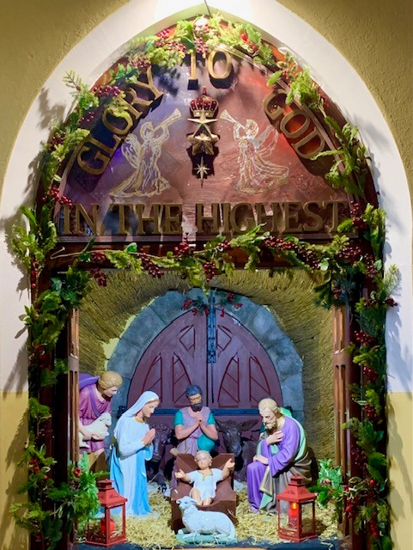



This Photo by Unknown Author is licensed under CC BY-NC
This Photo by Unknown Author is licensed under CC BY-NC
O COME LET US
ADORE HIM
JESUS CHRIST OUR LORD

