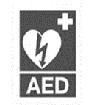

++ h
LISTOWEL PARISH NEWSLETTER
26th Sunday in Ordinary Time 28th September 2025
PRIEST ON DUTY this Sunday, Fr. Hanafin, 0878341083

Declan Canon O’Connor P.P. V.F. - Parish Office (Mon – Fri 10am – 1pm & 2pm – 5pm) 068-21188.Email: listowel@dioceseofkerry.ie. www.listowelparish.com to stream masses, forms & info. Notices for Newsletter in by 2.00pm on Thursdays. Booking of Masses: All mass intentions, must be booked at least a week before because the newsletter is a week ahead. After hours emergency number 0870908949.
Funerals take place on weekdays at 11.30am. Baptisms Saturday’s at 4pm.

d

MASSES THIS WEEK 28th - 5th October
Sat 27th | Eilzabeth Barrett, Golf View /  Bernie O Connell, Lyreacrompane & Cahirdown /  Maureen & Michael Clifford, Mitchelstown /  Mai & Michael Ferris, Asdee | Vigil  6.15pm
Sun 28th | People of the Parish | 9.00am
Sun 28th | Peg O Sullivan, Bedford, 1st Anniversary /  Peggy O Connor, Market St. & Clieveragh /  Benny McNamara & dec. family, Dromclough /  Jimmy Griffin, O’Connell’s Ave. /  Anne Wixted, Ballinruddery | 11.30am
Mon 29th | Dan McCrohan, Knightstown, Valentia Island, recently deceased /  Patrick (Padneen) Moran, Caherciveen, 20th Ann. | 10:30am
Tues 30th | Kathy Harnett, Church St. Birthday Rem. | 10:30am
Wed 1st | Angela Caslin, Jack & Mamie O Conor | 10:30am
Thurs 2nd | St. Michael’s College Mass | 10:30am
Fri 3rd | Special Intention | 10:30am
Fri 3rd | St. Padre Pio & 1st Friday evening mass | 6.15pm
Sat 4th | Noreen Keane Brennan, Months Mind /  Tim & Moira Griffin, Coolagown /  St. Michael’s College 50th class reunion, deceased former students: Fr. Pat Moore, Asdee, Alfe Neville, Bedford, Kieran Keane, Lixnaw, Anthony Lyons, Guhard, Maurice Walsh, The Square, Jim O Connor, Kilmorna, Pat Kenney, Convent St.,  Thomas Scannell, Skehenerin, & Daniel O Mahony, Lisselton | 10.30am
Sat 4th | Tom McCarthy, Coolnaleen / Jim Sheahan, Greenville /  Tim & Babe O Sullivan, St. Brendans Terrace /  Ellen, William & John Gerard McMahon, Gortalanna & Carrueragh / Peter Anthony Dowling & Christpher Smyth, Courthouse Rd & Church St. | Vigil  6.15pm
Sun 5th | Eamon & Una Mulvihill, Athea | 9.00am
Sun 5th | Michael McCarron, Gurtinard /  Peter Kelly, Ballinorig, Tralee / Paddy O Sullivan & dec. family, Meen | 11:30am

RECENT DEATHS: Peter McGrath, Cluain Doire.
Madeline Mulvihill, Clieveragh.
Grazyna Guzik, Upper William St.
Mary Shanahan, Dromin Green.

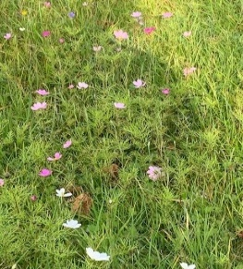
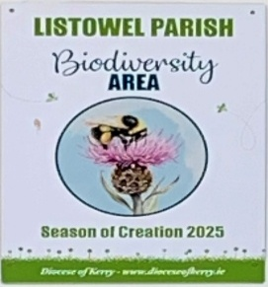
LISTOWEL PARISH MARKS THE SEASON
OF CREATION: with a little biodiversity area within the Presbytery grounds

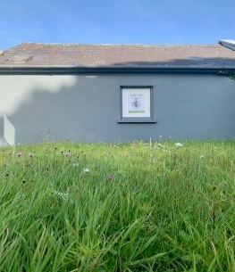
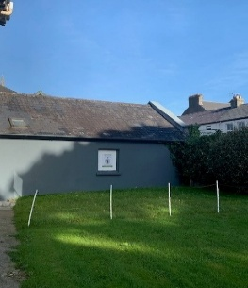
The Season of Creation is marked throughout the Christian world from 1st September to 4th October (Feast of Saint Francis of Assisi) and celebrates the joy of creation as well as encouraging awareness-raising initiatives to protect the natural environment. This year’s Season of Creation has as its theme “Peace with Creation”, inspired by the passage from Isaiah 32:14-18; Let us come together in hope of a peaceful Earth

CHURCH NOTICES
PARISH OFFICE will open at a later time of 11am. On Tuesday next 30th Sept as the Secretary will be attending a Kerry Diocesan Zoom meeting re garda vetting.
COMMUNION CALLS TO THE SICK & HOUSEBOUND: Fr. Declan will be making calls to the Sick and housebound on Tuesday afternoon. If anybody would like a visit with the sacraments, please ring the parish office before Monday morning 068-22188.
AUTUMN DUES: thanks to those who have dropped them in already. That is the special envelope with the yellow stripe in your envelope box. Alternatively, there are some loose ones at the back of the church or use any envelope. Drop into the offertory plate or Parish Office at any time throughout the month of September. Your support is very much appreciated. Thanks
REMINDER BOOKING OF MASSES All mass intentions must be booked at least a week in advance. Also, with more intentions happening each day the maximum number of names that can be given into one intention is four names. Thanks for your co-operation. The diary for 2026 will be open the first week of October 2025 to book masses for 2026.
ST. MICHAEL’S WELL LIXNAW will hold their annual Masses on Feast Day of St Michael Monday on 29th September at 12 noon and 7.30pm. All welcome.
THIS YEAR IS 1700th ANNIVERSARY of the first Council of Nicaea. On Sunday 5 October 2025 we join with Christian Churches throughout Ireland to mark and remember Nicaea and the Nicene Creed which came from it. We hold this creed in common with Christians for the last 1700 years, around the world and across the traditions. This Sunday is an opportunity for shared witness and reflection on the core beliefs that unite us in Christ.

