

++ h
LISTOWEL PARISH NEWSLETTER
23rd Sunday in Ordinary Time 7th September 2025
PRIEST ON DUTY this Sunday, Fr. Jerry Keane, 0872844649

Declan Canon O’Connor P.P. V.F. - Parish Office (Mon – Fri 10am – 1pm & 2pm – 5pm) 068-21188.Email: listowel@dioceseofkerry.ie. www.listowelparish.com to stream masses, forms & info. Notices for Newsletter in by 2.00pm on Thursdays. Booking of Masses: All mass intentions, must be booked at least a week before because the newsletter is a week ahead. After hours emergency number 0870908949.
Funerals take place on weekdays at 11.30am. Baptisms Saturday’s at 4pm.

d

MASSES THIS WEEK 7th – 14th September

Sat 6th | Caroline Enright, Feale Drive /  Michael Whealan, Market St. /  Monty Leahy, Clounmacon /  Nora Browne, Coolagown /  Brendan Hynes, Firhouse, Co Dublin /  Barty O Driscoll, Tanavalla /  Johnny Walsh, Listowel & Cork /  Tony O Callaghan, Cahirdown | Vigil  6.15pm
Sun 7th | People of the Parish | 9.00am
Sun 7th | Joan Dore, Charles St. | 11.30am
Mon 8th | Sean Buckely, 1st Anniversary & Hannah, Vera, Pat & Margaret Buckley, Gortnaminch | 10:30am
Tues 9th | Amedée Crowley, Lower William St. | 10:30am
Wed 10th | Special Intention / Sally O Neill, Cahirdown | 10:30am
Thurs 11th | Oliver O Neill, Cahirdown / Michael & Mary O Keeffe, Moyessa | 10:30am
Fri 12th | Chole McCool, Feale Drive | 10:30am
Sat 13th | Mary Reidy, Killocrim, Months Mind /  Betty Moriarty, Moyessa /  Mary Walsh nee McCarthy, Skull / John O Keeffe, Greenville /  Ned McGrath, Woodford | 10.30am
Sat 13th | Maire Shaw nee Nelligan, Colbert St. & New Jersy, 1st Anniversary & Joe Shaw New Jersy, Months Mind /  Patsy Stack, Gortcreen / Padraig Kelly, Bridge Road /  Maureen & Michael Clifford, Mitchelstown /  Anne & Patrick Carey, Ballygologue Rd / Dan Broderick, Bunagara | Vigil  6.15pm
Sun 14th | Sheila Taylor Behan, Fourhane, 1st Anniversary | 9.00am
Sun 14th | Patrick Foley, Well St. Ballylongford /  Margaret Peggy Gannon, College Lawn | 11:30am

ANNIVERSARY REMEMBRANCE: Nora Flaherty nee Carroll, O’Connell’s Ave.

KERRY DIOCESAN COLLECTION: Diocesan Needs will take place at all masses next weekend 6th & 7th September after communion.
LECTIO DIVINA will recommence on Thursday next 11th September at 11am in the Parish Meeting Room adjacent to the Church. Lectio Divina is a prayerful, meditative method of reading and reflecting on the gospel bringing about an awareness of how the gospel impacts on our lives today. We will start with tea and biscuits. New members welcome. For more information contact Bridie 0879828271.
MEDJUGORJE PRAYER MEETING will take place Monday 8th September straight after 10:30am. mass in the parish meeting room.

Canonisation of Bl. Carlo Acutis
& Bl. Pier Giorgio Frassati
Pope Leo XIV will canonise both Blessed Carlo Acutis and Blessed Pier Giorgio Frassati in St. Peter’s on Sunday September 7th 2025. The Mass commences at 10.00 am Rome time (9.00 am Irish time). Blessed Carlo Acutis will become the first millennial Saint and is very popular here in Ireland especially among young people. The Mass will be broadcast by RTÉ One television at 10.15 am this Sunday 7th September.

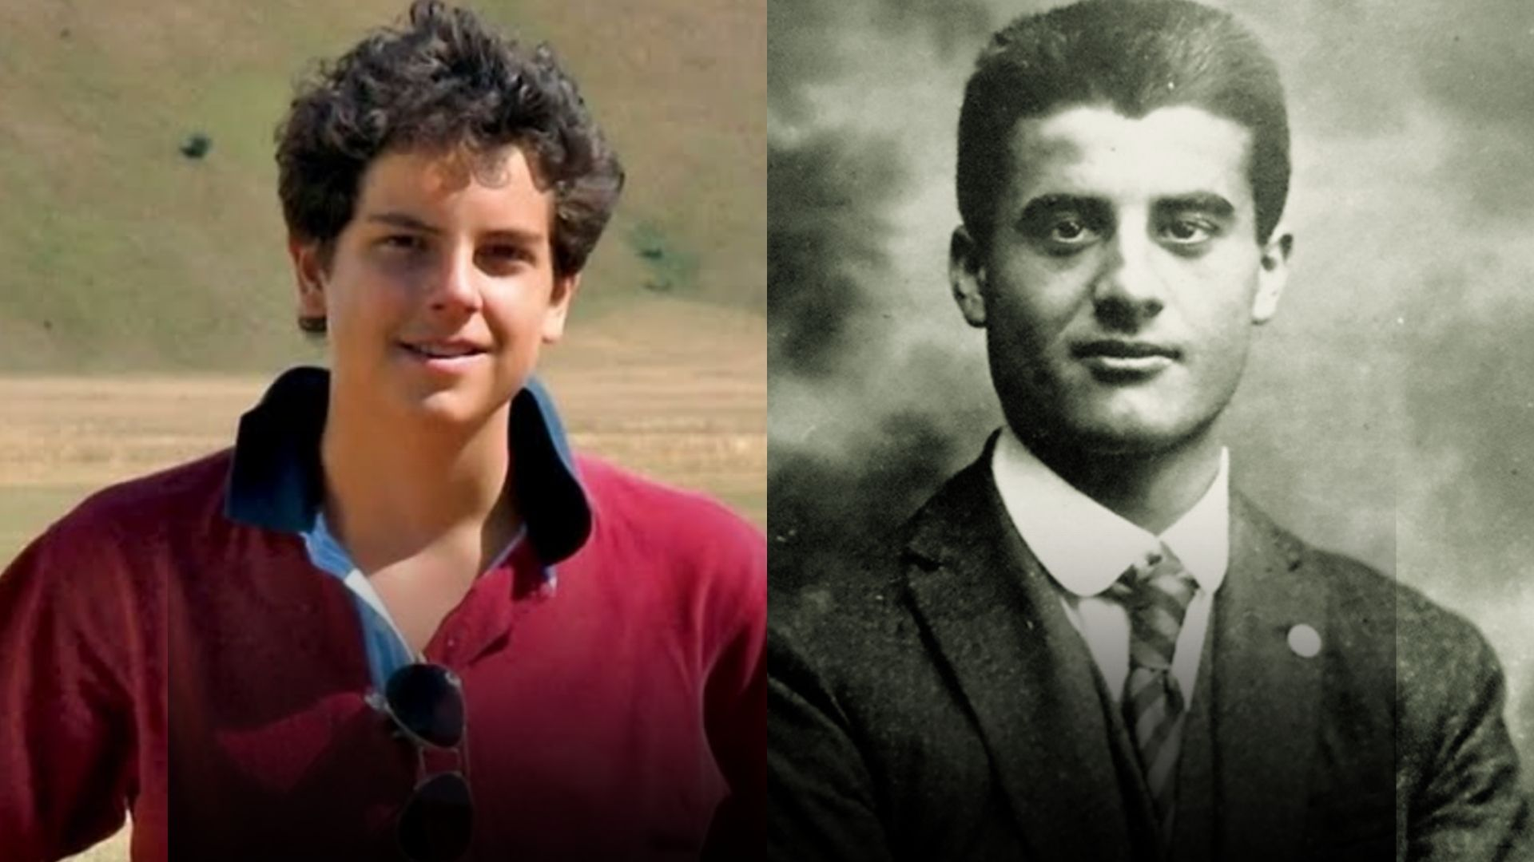

CHURCH NOTICES

AUTUMN DUES: thanks to those who have dropped them in already. That is the special envelope with the yellow stripe in your envelope box. Alternatively, there are some loose ones at the back of the church or use any envelope. Drop into the offertory plate or Parish Office at any time throughout the month of September. Your support is very much appreciated. Many thanks
ST. PADRE PIO GROUP TO KNOCK 21st September 7:30am. contact Bernadette on 0876019474.
PATTERN DAY MASS "Come celebrate Our Lady’s Birthday with us in beautiful Ballyheigue. Bishop Ray Browne will lead our Pattern Day Mass at 11.00am on Monday Sept 8th, in Our Lady’s Well and Grotto. Everyone is warmly invited. Plenty of free parking."
DIOCESE OF KERRY CELEBRATE SEASON OF CREATION Join the online launch of a short documentary: on Wednesday 10th Sept at 7.30pm, featuring a journey around the diocese to see what a parish, schools and an individual are doing to return to nature and protect biodiversity. Link on www.diocseofkerry.ie
COMMUNITY NOTICES
LISTOWEL ACTIVE RETIRED Resume on Tuesday 9th September 2.30pm. to 4.30pm. in St. Patrick’s Hall. New members always welcome to join.
LISTOWEL DUAGH COMHALTAS: New term registration is happening Classes are on Saturday’s Separate classes for children and adults. Come along and join us to learn music, song,
dance and fun in a relaxed setting. Please text/WhatsApp message to 087 935 4607 or contact us via the Listowel Duagh Comhaltas Facebook >page for more information.
TEACH SIAMSA FINUGE invites you to join our Creative Communities Project from 10th September – featuring North Kerry, Sean Nós, Set and Ukrainian dance, plus heritage talks. Nominal fee. Details: Eventbrite, Facebook, or email teachsiamsafinuge@gmail.com.

NORTH KERRY COMMUNITY CHOIR Join Us! Simple vocal exercises and a variety of Songs, heartwarming and uplifting! Tuesday 9th September 12:30pm. – 1.30pm. St. Patrick’s Hall, Upper William St., Listowel. Director: Mary Culloty O Sullivan, contact 0879222753. All welcome.
LISTOWEL KARATE CLASSES: Kerry Martial Arts School are recommencing karate and self-defence classes in Presentation Secondary School Hall on Monday 8th September. All ages from 4 to adults welcome at 6pm. Contact (089) 490 7724 for further information or search Kerry Martial Arts School on Facebook.

