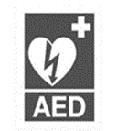

++ h
LISTOWEL PARISH NEWSLETTER
17th Sunday in Ordinary Time 27th July 2025
PRIEST ON DUTY this Sunday, Fr. Declan, 0872928949

Declan Canon O’Connor P.P. V.F. - Parish Office (Mon – Fri 10am – 1pm & 2pm – 5pm) 068-21188.Email: listowel@dioceseofkerry.ie. www.listowelparish.com to stream masses, forms & info. Notices for Newsletter in by 2.00pm on Thursdays. Booking of Masses: All mass intentions, must be booked at least a week before because the newsletter is a week ahead. After hours emergency number 0870908949.
Funerals take place on weekdays at 11.30am. Baptisms Saturday’s at 4pm.

d

MASSES THIS WEEK 27th – 3rd August
Sat 26th | Irene O Connor, Months Mind & Michael O Connor, Ballyduhig / Diane Moloney, Stokers Grove, recently deceased /  Michael Hennessy, Billerough /  John Lynch Knockane & Anne Beresford nee Lynch /  Nancy & Pat McAuliffe, Bedford & Lisa McAuliffe & Ken Hatton, Sydney / Michael & Teresa Bambury both birthday rem., Gurtaglana & John Gerard McMahon, Carrueragh /  Edward, Mary & Jack Carmody, Knockanure | Vigil  6.15pm
Sun 27th | Albert Byrne, Dublin / Brenda O Connor, Convent St. | 9.00am
Sun 27th | Pa Lyons, O’Connell’s Ave., Months Mind /  Paddy O Donnell, Knockane /  Byran O Connor, O’Connell’s Ave. & Kent England /  Martin Scanlon, 70th Birthday rem. Ballygologue Pk. /  Sharon Moriarty & dec. family, Knockroe Drive | 11.30am
Mon 28th | Mass card intention | 10:30am
Tues 29th | Mary Stack, William Street, 1st anniversary | 10:30am
Wed 30th | Bill & Pat Kearney, Clieveragh Park | 10:30am
Thurs 31st | Private Intention | 10:30am
Fri 1st | Mary O Connell nee Lyons, Rathea, Birthday Remembrance | 10:30am
Fri 1st | St. Padre Pio & 1st Friday evening mass | 6.15pm
Sat 2nd | Special Intention | 10.30am
Sat 2nd | Mary O Connell nee Lyons, Glenderry, Rathea, Months Mind /  Jean Sugrue, Clieveragh Downes /  Christy Angland, Knockane | Vigil  6.15pm
Sun 3rd | People of the Parish | 9.00am
Sun 3rd | Kevin McCarron, Beechgrove, Months Mind /  Nora Prenderville, Clieveragh Downes, 1st Anniversary /  Eileen & Jeremiah Hannon, Bromadera, Lyreacrompane | 11:30am

DEATH NOTICE Richard O Shea, William Street.

ANNIVERSARY REMEMBRANCE Kevin McAuliffe, Charles St. / Larry Barry, Greenville /

SPECIAL DIOCESAN COLLECTION: For the Pastoral Centre will take place on Sunday next August 3rd immediately after Holy Communion in all our Churches. The John Paul II Pastoral Centre in Killarney acts as a focal point for the catechetical and adult faith education programmes of the Diocese and supports Primary and Post Primary Religious Education.

CHURCH NOTICES

ST. PADRE PIO & FIRST FRIDAY EVENING MASS: Friday next (1st Aug.). The St. Padre Pio & 1st Friday evening mass, beginning with the Rosary at 6pm. Evening Mass at 6.15pm. followed by the Padre Pio prayers & Benediction, By Fr. Martin Hegarty.
THE COMMUNAL FIRST SATURDAY DEVOTIONS will be held the first Saturday of the month 2nd August, commencing at 9.45am. in St. Mary’s Church Listowel. Introductory Prayers 9.45am. Followed by the Rosary, 15 Min. Mediation after Mass, Confession available.
COMMUNITY NOTICE
🩸 HELP SAFEGUARD OUR HOSPITAL BLOOD SUPPLIES THIS SUMMER 🩸
As we all enjoy the well-earned break of the summer holidays, we’re asking people not to forget that Irish hospitals still need blood every single day—especially during the busy summer season. At this time of year we are challenged by people taking their well-deserved Summer holiday. This is compounded by a falloff in clinic attendance due to the recent warm weather. It is imperative that we also build blood stocks in advance of the August bank holiday weekend, But Irish Hospital’s demand for blood continues to rise month on month. 65% of blood donations goes to support Irish cancer patients and over 5% supports childbirth. Each donation has the potential to benefit three patients. If you're a regular donor—or if you've ever thought about giving blood—please consider coming along and helping us protect hospital patients across the country.
📍 BALLYBUNION COMMUNITY CENTRE
Thursday 31st July 4:50pm – 8:10pm
New and returning donors are very welcome at all clinics.
Phone 1800 222 111 for appointment. Your donation can make a life-saving difference.


Best of luck to the
Kerry football team at the
All-Ireland Senior Football
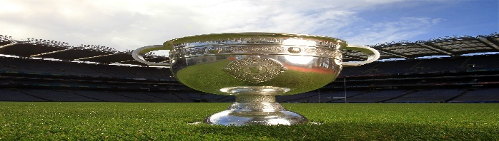
Championship final this Sunday

