S T. M A R Y’ S C H U R C H L I S T O W E L

MASSES
Christmas Eve | Nell & Jack O Connor, Denis Kelly & Jade Foley, Gortcreen / Pat, Catherine, Dan & Susanna Browne Church & Dromin /  Maire Fealy, Courthouse Rd, Birthday Remembrance / Margaret Carmody, Knockroe Drive & Moybella /  Oliver O Neill, Cahirdown /  Patrick, Kathleen, Patsy & Mai Stack, Gortcreen /  Teresa & Billy O Sullivan & Mary Gallagher, England /  Deceased members of the Fealey, Walsh & Lyons Families, Ennismore, Craughatoosane & Ballygarrett. | 4pm
 | Michael & Pauline Kennedy, Ballysimon, Limerick & daughter Yvonne Moloney nee Kennedy, rec deceased, birthday rem /  Michael McDonnell, Clare & London /  Laurence, Ellen & Maurice Collins, Kilmorna /  Margo Sharp, Listowel & England /  Michael, Mary, Michael Gerald & Eamon O Connor, Patrick St.  Michael Heaphy, Ballylongford /  Tommy & Anne O Connor, Asdee | 6pm
 | Bill O Sullivan, Coilbee & dec members of the O’Sullivan & Browne Families /  Michael Molyneux, O’Connell’s Ave. /  Bridie Sayers, Greenville /  Bridie Mulligan & Jule Scanlon, Bridge Rd. /Deceased members of the Corridan, Fitzgerald & Moriarty families / Philomena Donnelly, Roscommon / Paddy & Eva Hogan, Ennis | 8pm
Christmas  Day | Jim & Anne O Sullivan, Charles St. / Lila Stack, Charles St. & Eileen Cotter, Glenoe / John O Brien, Cahirdown / Deceased members of the O’Brien, Doherty & Hallacy Families /  Katheen, Tom & Josie Doyle & Bridie Hassett, Bridge Rd. /  Maureen Molyneaux, Bedford & London | 9.00am
 | Charlie Chute, Greenville / Rich Kissane, Clountubird / Daniel, Elizabeth & Angela Kearney, Moyvane / William, Ellen, Mairead & Anne Walsh, Pollagh / Hannah Mulvihill, Bedford /  Betty Kennelly, Ashfield /  Maire & John Roche, Ballylongford & Jack & Kathleen Roche, Cork &Margret & Louis Keating, Ballylongford | 11.30pm

May the peace of Christ be with you and may you enjoy
a very Happy & Holy Christmas
THE BIRTH OF JESUS CHRIST 25TH DEC.

Thank You – ‘Míle Buíochas’
As we celebrate Christmas and bring the year 2023 to a close, I feel that I’m very privileged and indeed it is my honour to continue working with you as your Parish Priest here in Listowel. I would like to take this opportunity to thank you sincerely for the support that you give to your Parish and to me personally throughout the year. It takes a lot of people to make a Parish active and to keep it going in these difficult and challenging times. It could not happen only that we are blessed with good staff, Parish Secretary Denise and both sacristans Helen and Martina and a lot of volunteers who are dedicated to our Parish. Many of you work behind the scenes and you might feel your work sometimes goes unnoticed, but each person in their own right play their part, and each does it so well. A special thanks to Fr. Martin, Fr. Jack, Fr. Brendan & Fr. Anthony of our Pastoral Area.

I thank the Parish Finance Council who keeps an eye on the Parish Finances. I thank the Parish Pastoral Council and the Safeguarding Committee for their support and guidance. Thanks to the Parish Liturgy Group who co-ordinate the various ministries and liturgies. The Eucharistic Ministers / Parish Youth Group / the Readers, the Collectors, the Counting Teams who count the parish offerings, the Parish Choir, the Parish Folk Group, their members, their directors and musicians. We are blessed to have Adoration of the Blessed Sacrament weekly in our Parish. Thank you all who make it possible. We have the Padre Pio Prayer Group & Legion of Mary who run their regular meetings - I’m not forgetting our Altar Servers, their parents and teachers for their support. You all do a great job, and your help is much appreciated.

To those who clean the church - not alone is this done for Christmas, but it is done quietly all year around. Those who donate flowers and look after both inside and outside the church and Presbytery grounds throughout the year. So many visitors remark on how well each place looks. This is a tribute to you, so take a bow. To those of you who put up the Crib and those who are available at moments notice to do the various maintenance jobs of the Parish throughout the year.

We are dependent on each other for friendship, support, and finance. Thank you for your generosity and kindness to your Parish and to me personally right throughout the year. I pray that God will bless and reward you and your family with all his gifts this Christmas and throughout the new year of 2024.

God Bless Fr. Declan

MASSES NEXT WEEK
(Tuesday 26th December to Sunday 31st January)

Tuesday 26th | Special Intention / Michael McCarron, Gortinard, Birthday Rem. / Edle O Halloran, Church St. & College Rd. Cork / Joe Barry of Swindon, England Late of Muckenaugh, Lixnaw and Knockane &  John Barry, Birmingham Lixnaw and Listowel | 10.30am
Wednesday 27th | Michael & Elizabeth Moore, Cahirdown & Henry Schmoll | 10.30am
Thursday 28th | Paul McCarthy, Tanavalla, 1st Anniversary /  John McCarthy, Tanavalla & Clare, 1st Anniversary /  Catherine & Jack Scannell, Bunagara & Skehenerin /  Deceased members of the Sweeny family, Convent St. / Michael O Connor, Springmount, Duagh / Frank & Bill Kelly, Dublin / Molly & Jack Nolan, Aviation Drive | 10.30am
Friday 29th | Angela Henigan McKeon, USA & The Square /  Ed Harnett, Hawthorn Drive / Special Intention /  Joan, Tom & Patrick Walsh, The Square | 10.30am
Saturday 30th | Fr. Brendan Dalton, Bridge Rd. /  Kit & Pat Dowling, Bridge Rd. | 10.30am
 | John Charlie O Sullivan, Killocrim / Angela & Mossie Carmody, Skehenerin / Maire Downey, Duagh & dec. family, Knockalougha / Anne Browne, Coolagown / Michael O Neill, Ballygologue Rd. / Nora Crane nee Fitzmaurice, Ennismore & England & dec. family | Vigil
Sunday 31st | Jacqueline & Eamon Roche & Christine Williams, O’Connell’s Ave. | 9.00am
 | Joe Carroll, St. Brendan’s Tce. / John O Mahony Ballygrennan / Tadgh Laide, Ballygologue Pk. /  Carmel Walsh, Ballygologue Pk. | 11.30am

PRIEST ON DUTY this Monday day Christmas Day Fr. Declan O Connor, 0870908949. Christmas Offering Envelopes: Many thanks for your generous Christmas Offerings already received. Should you not have an envelope, there may be some at the back of the church or use any envelope. Thank you for your ongoing support.

Parish Office Closed for Christmas:
1p.m. Friday, Dec. 22nd to 10am. Wednesday January 3rd, 2024

ST. MARY’S CHURCH LISTOWEL
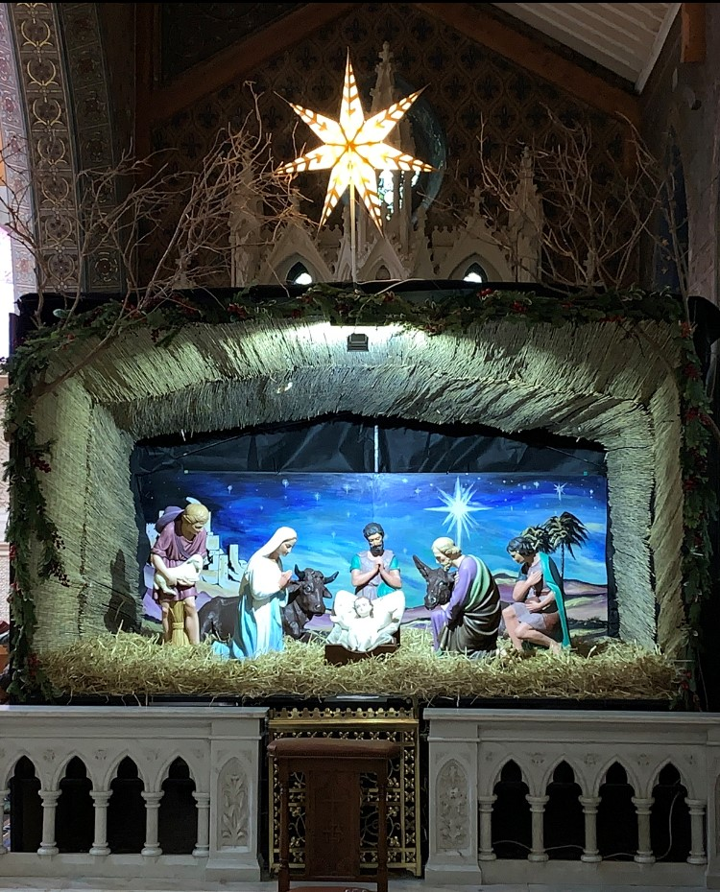
CHRISTMAS DAY 2023

O COME LET US
ADORE HIM
JESUS CHRIST OUR LORD

