S T. M A R Y’ S C H U R C H L I S T O W E L

MASSES
Christmas Eve | Maire Fealey, Courthouse Road, Birthday Remembrance / Patrick, Kathleen, Patsy & Mary Stack, Gortcreen /  Oliver O Neill, Cahirdown /  Christopher Smythe, England & Listowel, Bir. Rem. /  Eily Mae & Daniel Lyons, Ballygarrett /  John, Ned & Paddy Fealey, Ennismore /  Joe, Hannah & Dan Wash, Craughatoosane & Michael McDonnell, Clare & London | 4pm
 | Laurence, Ellen & Maurice Collins, Kilmorna /  Michael, Mary, Michael Gerard & Eamon O Connor, William St. /Margo Sharpe, Listowel & England / Thomas & Annie O Connor, Asdee / Con, Paddy & Eileen Leahy & Caroline Enright /Margaret Carmody, Knockroe Drive / Michael & Pauline Kennedy, Limerick / Maurice & Mary O’Connell & Sr. de Lourdes, O’Connell, Grogeen. | 6pm
 | Bill O Sullivan, Coilbee & deceased members of the O’Sullivan & Brown families & Marcella Holly / Padneen Moran, Dan Foley & Stephen Foran, Caherciveen & Listowel / Michael Molyneaux, O’Connell’s Ave. / Deceased members of the Corridan, Moriarty & Fitzgerald Families / Oliver O Neill, Tom & Josie Doyle, Bridie Hassett & Noreen Guiney, Bridge Rd. & Moyvane / Michael Heaphy, Ballylongford | 8pm
Christmas  Day | Lilia Stack & Eileen Cotter nee Stack, Charles St. & Glenoe / Jim & Anne O Sullivan, Charles Street / Jackie McGillicuddy & dec. family members / Diana McElligott, Tralee Rd / Betty Kennelly, Ashfield / Angela Kearney, Cahirdown & Moyvane | 9.00am
 | Maureen Molyneaux nee Pellican, London & Bedford 1st Anniversary / Charlie Chute, Greenville / Rich Kissane, Clountubird / Jeremiah O’Driscoll, Hermitage Farm, Ballybunion Road / John O Mahony Ballygrennan / Deceased members of the Kearney, Barrett, Walsh & Mulvihill Families, Bedford, Moyvane, Glin & Pollough / Sr. M. Vincent, Dublin, Sr. M. Clement & Sr. M. Vianney, Castleisland /  Michael McCarron, Gurtinard (Bir Rem) | 11.30pm

May the peace of Christ be with you and may you enjoy
a very Happy & Holy Christmas
THE BIRTH OF JESUS CHRIST 25TH DEC.

Thank You – ‘Míle Buíochas’
As we celebrate Christmas and bring the year 2022 to a close, I feel that I’m very privileged and indeed it is my honour to work with you as your Parish Priest here in Listowel. I would like to take this opportunity to thank you sincerely for the support that you give to your Parish and to me personally throughout the year. It takes a lot of people to make a Parish active and to keep it going in these difficult and challenging times. It could not happen only that we are blessed with good staff, Parish Secretary Denise and both sacristans Helen and Martina and a lot of volunteers who are dedicated to our Parish. Many of you work behind the scenes and you might feel your work sometimes goes unnoticed, but each person in their own right play their part, and each does it so well. A special thanks to Fr. Martin, Fr. Jack, Fr. Brendan & Fr. Anthony of our Pastoral Area.

I thank the Parish Finance Council who keeps an eye on the Parish Finances. I thank the Parish Pastoral Council and the Safeguarding Committee for their support and guidance. Thanks to the Parish Liturgy Group who co-ordinate the various ministries and liturgies. The Eucharistic Ministers, the lectors / readers, the collectors, the counters who count the offerings, the Parish Choir, the Parish Folk Group, the members, their directors and musicians. We are blessed to have Adoration of the Blessed Sacrament weekly in our Parish. Thank you all who make it possible. We have the Padre Pio Prayer Group & Legion of Mary who run their regular meetings - I’m not forgetting our Altar Servers, their parents and teachers for their support. You all do a great job, and your help is much appreciated.

To those who clean the church - not alone is this done for Christmas, but it is done quietly all year around. Those who donate flowers and look after both inside and outside the church and Presbytery grounds throughout the year. So many visitors remark on how well each place looks. This is a tribute to you, so take a bow. To those of you who put up the Crib and those who are available at moments call to do the various maintenance jobs throughout the year.

We are dependant on each other for friendship, support, and finance. Thank you for your generosity and kindness to your Parish and to me personally right throughout the year. I pray that God will bless and reward you and your family with all his gifts this Christmas and throughout the new year of 2023.

God Bless Fr. Declan

MASSES NEXT WEEK
(Monday 26th December to Sunday 1st January)

Monday 26th | Edel O Halloran, Church St. | 10.30am
Tuesday 27th | Michael, Elizabeth & Michael Moore, & Henry Schmoll, Cahirdown | 10.30am
Wednesday 28th | Michael O Connor, Springmount, Duagh /  Molly & Jack Nolan, Aviation Drive /  Deceased members of the Sweeney Family, Convent St. / Catherine Scannell Skehenerin /  Mary & Batty Lynch, Lisselton & dec. mem of the Lynch & Hartney families | 10.30am
Thursday 29th | John Charlie O Sullivan, Killocrim /  Con, Nancy & John Keane, Church Street /  Angela Henigan McKeon, USA & The Square /  John Finnegan, Killocrim, Birthday Rem. | 10.30am
Friday 30th | Kit & Pat Dowling, Bridge Rd /  Carmel Walsh, Ballygologue Pk. /  Delia Barry nee Bunyan, Greenville | 10.30am
Saturday 31st | Noreen McNamara, Tullahinell, Asdee | 10.30am
 | Peggy O Dell Moloney & dec. family, Charles St. /  Anne Browne, Coolagown /  Eamon Roche & Jacqueline Roche, O’Connell’s Ave. /  Nora Creane, England & Ennismore & dec. Fitzmaurice family / Bridie Sayers, Greenville | Vigil
Sunday 1st | People of the Parish | 9.00am
 | First Friday Call Intentions | 11.30am

PRIEST ON DUTY this Sunday Christmas Day
Fr. Declan O Connor, 0870908949

Christmas Offering Envelopes: Many thanks for your generous Christmas Offerings already received. Should you not have an envelope, there may be some at the back of the church or use any envelope. Thank you for your ongoing support.

Parish Office Closed for Christmas:
From 1.00 p.m. Friday, Dec. 23rd to
10.00 a.m. on Tuesday January 3rd, 2023

ST. MARY’S CHURCH LISTOWEL
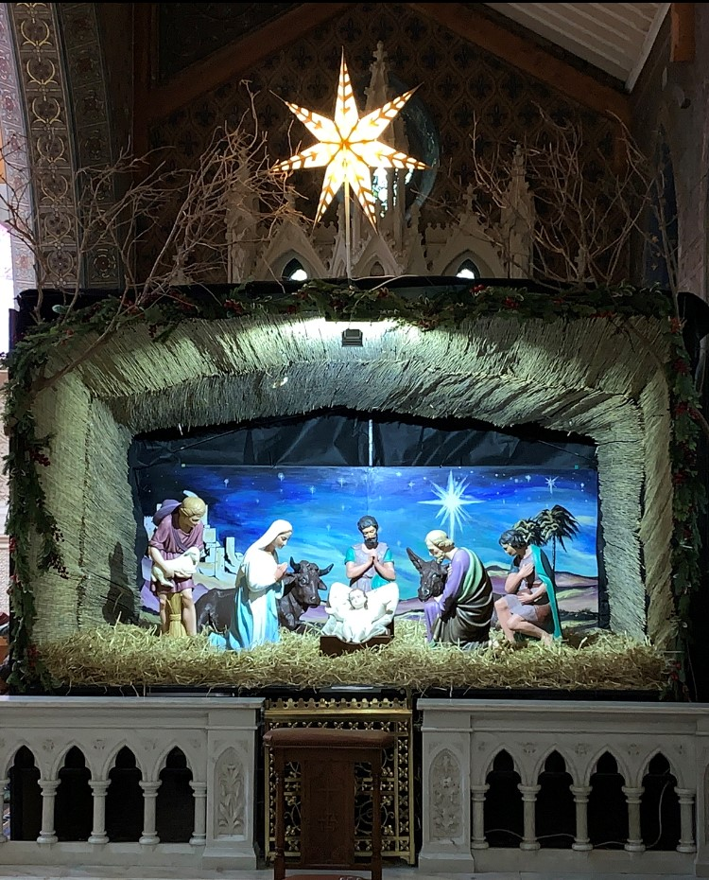CHRISTMAS DAY 2022

O COME LET US
ADORE HIM
JESUS CHRIST OUR LORD

