S T. M A R Y’ S C H U R C H L I S T O W E L

MASSES
Saturday  Christmas Eve | Maurice & Mary O Connell & Sr. De Lourdes, Grogreen /  Michael & Pauline Kennedy, Limerick /  Daniel & Elizabeth Kearney, Moyvane &  William, Ellen, Mairead & Anne Walsh, Pollough & Hannah Mulvihill, Bedford / Sr. Maura Carmody, Patrick St  Michael McDonnell, Co Clare & London &  Katie O Brien, London / John Mulvihill, Coolaclarig /  Margaret Carmody, Knockroe Drive /  Ned, Paddy & John Fealy, Ennismore &  Joan, Hannah & Dan Walsh, Craughatoosane / Laurence, Ellen & Maurice Collins Kilmorna & Michael, Mary, Michael Gerard & Eamon O Connor, Patrick Street /  Kathleen & Michael Browne, Co Waterford /  Robert & Catherine Stack, Moyvane &Maureen Stack & Sr. Julianna Culhane / Pat & Catherine Browne, Dromin Rd. &  Dan Browne, Church St./ Josie Doyle & Bridie Hassett, Bridge Rd. Deceased Members of the Lucy, Buckley & Jordan Families, Kilkenny, Charles St. & Finuge / Deceased members of the Corridan, Fitzgerald & Moriarty Families / Anne Walsh nee Lynch & John Lynch O’Connell’s Ave. | Vigil 6.15pm
Saturday  Christmas Eve | Christmas Night Mass of the Nativity | 9.00pm
Sunday  Christmas  Day | Charlie Chute, Greenville / Jim & Anne O’Sullivan, Charles St / Patrick, Kathleen & Patsy Stack, Nell & Jack O’Connell, Denis Kelly, Bill O Sullivan, Tade Foley & deceased members of the stack, Foley & Buckley Families Gurtcreen | 9.00am
Sunday  Christmas  Day | People of the Parish | 12.00pm
Monday 26th | Cathy & Jack Quilter, Kilflynn /  Bernadette Stokes & Deceased Family Members | 10.30am
Tuesday 27th | Bill O Sullivan & Deceased members of the O’Sullivan & Browne Families, Coilbee / Special Intention /  Deceased Members of the Sweeney Family, Convent St. | 10.30am
Wednesday 28th | Jackie Reidy, O’Connell’s Ave. 1st Anniversary /  Michael O Connor, Springmount, Duagh /  Molly Nolan, Aviation Drive | 10.30am
Thursday 29th | Edel O Halloran, Church Street | 10.30am
Friday 30th | Pat & Kitt Dowling, Bridge Road | 10.30am
Saturday 31st | Nora Leahy, Ballygologue, Months Mind | 10.30am
Saturday 31st | Peggy Harrington nee Lyons, Birmingham, & Ennismore, Recently Deceased / Bridie Sayers, Greenville /  Carmel Walsh, Ballygologue Pk. / John Charlie O Sullivan, Killocrim / Peggy O Dell Moloney, Charles St. / | Vigil  6.15pm.
Sunday  1st January | Brendan Guiney, Charles Street /  Larry Senior & Dora Buckley, Tanavalla | 9.00am
Sunday  1st January | Joe Carroll, St. Brendan Tec. / Tadgh Laide, Ballygologue Pk. / John O Mahony, Ballygrennan /  Micháel O Sullivan, Clieveragh Downs | 12.00pm

THE BIRTH OF JESUS CHRIST 25TH DEC.

RECENT DEATHS William Gorman, Knockane. / Eamon Browne, Coolagown & Dublin. / Nora Crane nee Fitzmaurice, England & Ennismore. / Sheila O Doherty nee Sheahan, Milltown & William St.
ANNIVERSARY REMEMBRANCE: Bridie Hannon, St. Brendan’s Tec., Ciss & John Hannon, Convent St. / Sr. Joan Harnett, Presentations Convent Killarney / Nora Naughton, Knockaclare, Lyreacrompane / Pat & Catherine Browne, Dromin Rd. / Deceased Members of the Shine Family, O’Connell’s Ave.
Thank You – ‘Míle Buíochas’
As we celebrate Christmas and bring 2016 to a close, I feel that I’m very privileged and it is my honour to work with you as your Parish Priest here in Listowel. I would like to take this opportunity to thank you the Parishioners, Fr. Martin Hegarty, Fr. Sean O Sheehy and Rev. Sean Jones (Deacon) sincerely for the support that you have given to the Parish and to me personally throughout the past year. It takes a lot of people to make a Parish active and to keep it going in these difficult and challenging times. In particular in recent times with the added duties of Duagh & Lyre Parish. It could not happen only that we are blessed with good staff, Denise (Parish Secretary) and Catherine & Helen (Sacristans) and a lot of volunteers who are dedicated to our Parish. Many of you work behind the scenes and you might feel your work sometimes goes unnoticed but each person in their own right plays their part and each does it so well.

I thank the Parish Finance Council who keeps an eye on the Parish Finances. I thank the Parish Pastoral Council and the Safeguarding Children Committee for their support and guidance. Thanks to the Parish Liturgy Group who co-ordinate the various ministries and liturgies. The Eucharistic Ministers, the Lectors / Readers, the Collectors, the Counters who count the offerings weekend after weekend, the Parish Choir, the Parish Folk Group, the members, directors and musicians. This year we formed a new Baptism Team who have been fantastic. We are blessed to have Adoration of the Blessed Sacrament weekly in our Parish. Thank you all who make it possible. We have the St. Pio Prayer Group who run their monthly meeting - and I’m not forgetting my Altar Servers, their parents and teachers for their support. You all do a great job and your help is much appreciated. To those who clean the church - not alone is this done for Christmas, but it is done quietly all year around. Those who donate flowers and look after both inside and outside the church and Presbytery grounds throughout the year. So many visitors remark on how well each place looks. This is a tribute to you, so take a bow. To those of you who put up the Crib and those who are available at a moments call to do the various maintenance jobs throughout the year.

We are dependant on each other for friendship, support and finance. Thank you for your generosity and kindness to your Parish and to me personally right throughout the year. I pray that God will bless and reward you and your family with all his gifts this Christmas and throughout the new year of 2017.
God Bless Fr. Declan O’Connor P.P.

CHRISTMAS OFFERING: Many thanks for your generous Christmas Offerings already received. Should you not have an envelope, there may be some at the back of the church or use any envelope. Thank you for your ongoing support.

May the peace of Christ be with you and may you enjoy
a very Happy & Holy Christmas
Nollaig Faoi Shéan is Faoi Mhaise Díbh go léir

A PRAYER FOR FAMILIES AROUND

THE CANDLE IN THE HOME

Jesus, Bless us this year.
Bless us with joy and with hope,
Forgiveness and love.
Bless us with the new life
of Your cross and resurrection.
May we join with you in spreading
the peace and love of the
Kingdom of God.
Amen.

Parish Office Closed for Christmas:
From 1.00 p.m. Friday, Dec. 23rd to
10.00 a.m. on Wednesday January 4th 2017

ST. MARY’S CHURCH LISTOWEL

CHRISTMAS DAY 2016
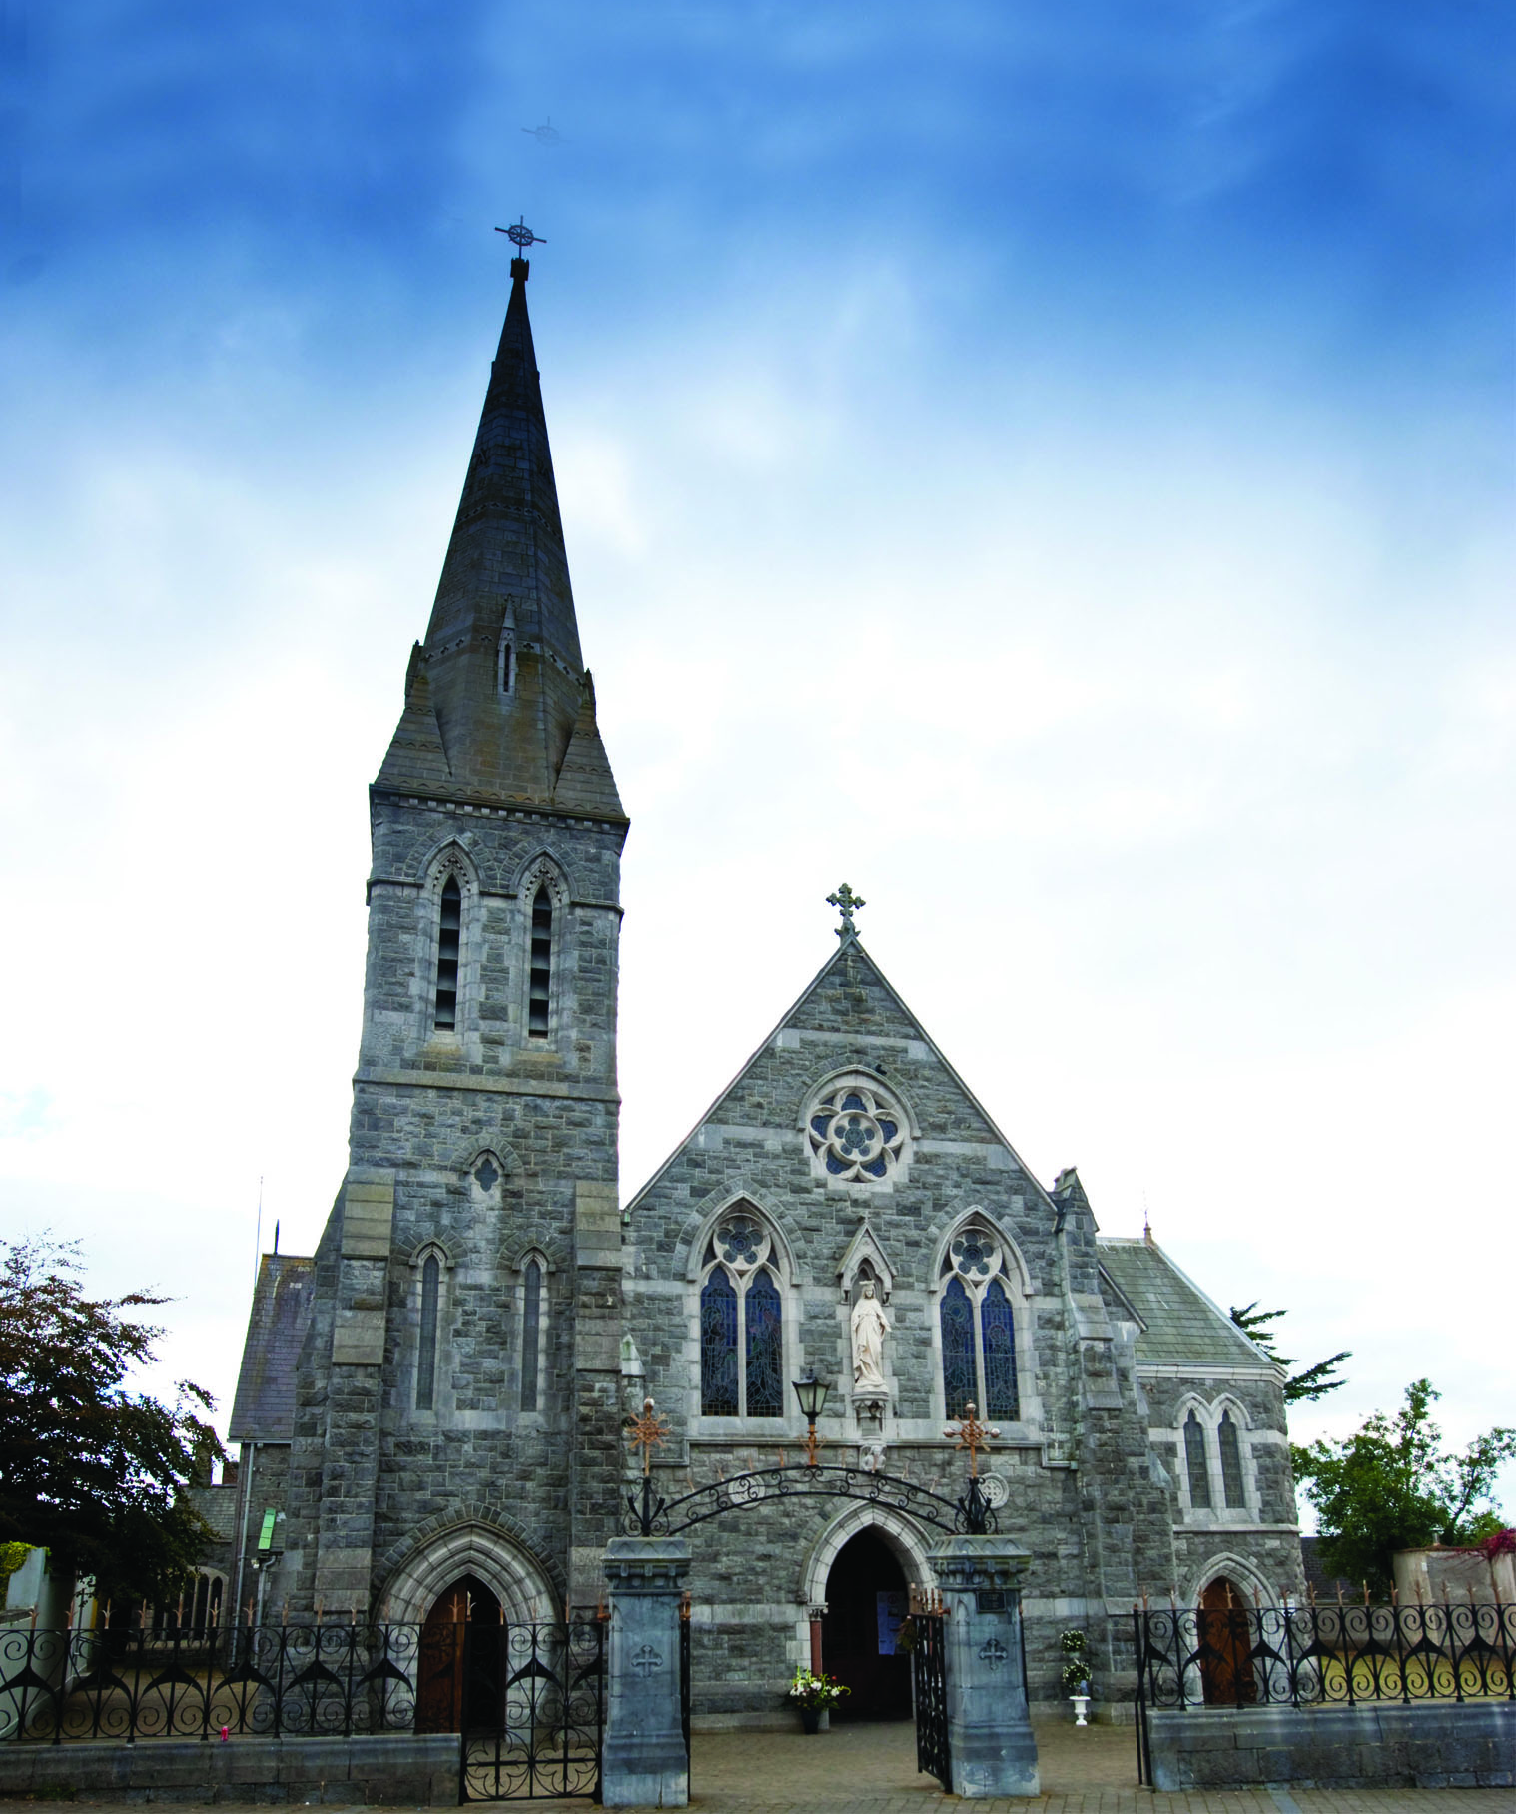

O COME LET US
ADORE HIM
JESUS CHRIST OUR LORD

