Your Wedding in
St. Mary’s Church, Listowel

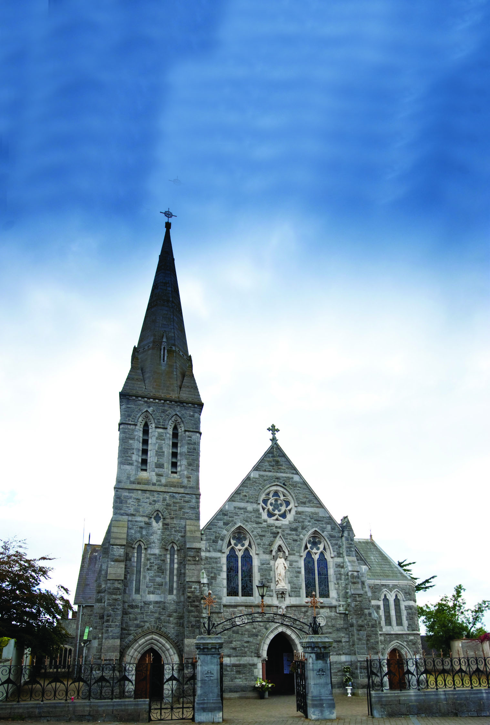

Congratulations to you on your engagement! We pray God’s blessing on you in this time of preparation and ask God’s guidance for you in your married life. Getting married in our Church means that you will be celebrating the Sacrament of Marriage, one of the seven sacraments in our Church, a time to be enriched with God’s grace.

We are happy to be a part of your Wedding preparations and hope the following information will be helpful to you.

In Planning to get married in the Catholic Church, the couple must be:
• at least one of the couple is Catholic
• both adults, 18 years or older
• be one male and one female
• Both must be free to marry in the Church (i.e. never have celebrated a religious or civil marriage, or if one has been married, they are either widowed or annulled). If you have questions about this, contact a priest immediately.
• Both understand and accept that marriage is a lifelong loving commitment, with faithfulness to each other, and are open to children in their marriage.
Arranging a Date, Time, Church and Priest
To make the arrangements for the date, time and Church of your wedding in our parish, you will need to contact the Listowel Parish Office (068 21188). You will then be asked to fill out a booking form and to give your offering to the Church within 2 weeks of booking, so as to confirm your commitment to that date, and to be sure of your booking. If we haven’t heard from you by the 2 weeks, we will presume you have made other arrangements and we will then be able to offer that date and time to others.
Regarding the Priest to celebrate your wedding: The Parish Priest will be delighted to celebrate the weddings of our parishioners. For those from outside our parish, we will do everything possible to facilitate them, however, due to our many other parish commitments, he may not be able. In that case – you can are welcome to make your own arrangements for getting a priest to celebrate your wedding (eg a priest who is a family relative of friend, a priest from your own parish etc. ).
Your Offering for the Wedding : We are most grateful for your generosity and support to the parish, and pray God’s blessing on the benefactors of our parish who have gifted us with such a beautiful church. As a guide, the following may be of help. The suggested offering for the church is €160.00 payable to the Parish Office at the time of booking your wedding. This offering includes €40.00 for the Sacristan who will be with you to make the preparations for the ceremony itself. Please note that this does not include the priest who will be celebrating your wedding Mass - you can make your own offering to him yourself, aware of his time with you in planning your wedding, assisting with the pre-marriage papers, the wedding practice, and on the wedding day itself. It is an offering and we appreciate and respect the different circumstances of each individual.
Church and Civil Requirements for your Wedding Ceremony
Civil Requirements of your Wedding
In celebrating your wedding with us, you will be celebrating a Catholic ceremony that usually has civil recognition. For the civil recognition, you must fulfil the legislation of the Irish State. It is your responsibility to contact the Civil Registration Office (locally at the Civil Registrar’s Office, Community Hospital Grounds, Listowel, or nationally at www.civilregistrationservice.ie) and give at least 3 months notice to the State to fulfil the legal requirements - If you are living outside the State you may need to allow extra time for this. When the registration is complete, you will be issued with a Marriage Registration Form (MRF). This is the legal form that you will keep in your possession and it will be signed on the day of your wedding by you, your witnesses, and by the priest. It is advisable for you to nominate someone who will take responsibility of this MRF, a legal document, taking it from the Church after signing, holding it for you in safekeeping before you return to the Civil Registration Office within a month.
Church Requirements for your Wedding
Pre-Marriage Course: Because your wedding is a special and important moment in your life, the Church wishes to ensure that you have the adequate space and preparation for you as a couple to reflect as you journey forward. With this in mind the Church requires a couple to undertake a Pre-Marriage Course. Nationally, the diocesan approved pre-marriage courses are facilitated by Accord (locally, Accord is located at St. John’s Parish Centre, Tralee 066-7122280/ accordtralee@eircom.net or John Paul II Pastoral Centre, Rock Rd, Killarney 064 6632644, or nationally at www.accord.ie). Contact them to organise your attendance on the course that best suits you. Ideally you should do this at least 6 months before your wedding, so that you have the time for reflection, without the pressures that wedding organising can bring.
Pre-marriage Papers: The Church wishes to ensure that everything is in order for your wedding to take place in our parish, and so you will need to complete Pre-Marriage Papers (Pre-nuptial Enquiry Forms). This gathers the details for the parish marriage register, to ensure that you are both free to marry in the Church, and that your understanding of marriage is the same as that of the Church. Please note that both of you need to fill out the pre-marriage papers with the priest of the parish where you are living, and he will then forward them to us. Ideally this should be done at least 2 months before the wedding, and if you are living outside the country you might need to allow extra time for this. To complete the pre-marriage papers you will include your baptismal certificate, your confirmation certificate and your letters to testify your freedom to marry.
Organising the Wedding Mass/Ceremony
Planning the Readings, Prayers etc: The ceremony is prepared with the priest who will celebrate your wedding, and he will be able to guide you in your planning. You will choose bible readings, and a Gospel, prepare Prayers of the Faithful (bidding prayers), and decide on the form of the vows you will be exchanging. The priest celebrating your wedding should have suggestions for you, as well as resources from your pre-marriage course.
Church Music: You should choose Church hymns or liturgical music that is suitable to the Church, to prayer and to the wedding ceremony. Secular songs are generally not appropriate for the Mass and Sacrament of Marriage. Please convey this to the singers/musicians, ask them for their suggestions from the rich store of liturgical hymns and music, and talk to your priest when confirming your music choice. Ask the singers/musicians to make contact with the Parish Sacristan before the day of the wedding to determine their location during the wedding ceremony.
Flowers, Candles etc: St. Mary’s Church has fine architectural beauty, so flowers should only be used sparingly. Artificial flowers and arches should not be used. Because of safety concerns, candles should not be used outside the sanctuary. No rice, confetti etc may be scattered on the Church grounds.
Photographers/ Video technicians: are welcome, provided that they are suitably dressed, remain outside the sanctuary during the Mass, and remember to protect the prayerfulness of the ceremony by not causing distraction. Please convey this to those you are engaging for this, either family members or professionals.
Wedding Practice: In booking your wedding practice, please arrange this with the priest celebrating your wedding, and arrange it too with the Parish Office for a suitable time for all.
Punctuality: We draw your attention to the fact that as you are planning your own wedding day, the Church is also available for other couples planning their own special day also, and for other Masses and ceremonies. We ask for you to make every effort in being punctual for your wedding practice and especially for the Wedding Ceremony itself, so that all may go calm and smoothly for yourself and for all others.
A Final Word: Please remember this in all the preparations for your wedding day, you should create the space for your own prayer and reflection, asking God to guide you as a couple long into the future. Deepen your faith by regularly attending Mass so that all will be familiar to you on your wedding day. Give thanks for the good example of marriage you have received from others. May the Peace of Christ ever dwell in your home;
May the angels of God protect it, And may the Holy Family of Nazareth be your model and inspiration.
THE PARISH OFFICE, Bridge Road, Listowel, Co. Kerry. Tel. (00353) 68 21188
email:listowel@dioceseofkerry.ie Parish Office Hours: Mon. to Fri. 10 a.m. – 1p.m. & 2pm – 5p.m.

