S T. M A R Y’ S C H U R C H L I S T O W E L
MASSES
Tuesday  Christmas Eve | Maurice, Mary & Sr. De Lourdes O’Connell, Grogreen /  Michael McDonnell, Clare & London /  Michael & Pauline Kennedy, Ballysimon, Limerick /  Josie Doyle & Bridie Hassett, Bridge Rd. /  Margaret Carmody, Knockroe Drive /  Laurence, Ellen & Maurice Collins, Kilmorna Michael, Mary, Michael Gerard & Eamon O’Connor, Patrick St. / John, Paddy, Ned Fealey, Ennismore, Joan, Hannah & Dan Walsh, Craughatoosane & Elie Mae & Daniel Lyons, Ballygratt / Marie Kelliher, Lartigue Village | Vigil 5.30pm
Tuesday  Christmas Eve | Rich Kissane, Clountubrid / Bridie Sayers, Greenville /  Dec. Mem. of the Corridan, Fitzgerald & Moriarty Families / Jack O Brien, Cahirdown | 8.00pm.
Wednesday  Christmas  Day | Deceased Members of the James Family, O’Connell’s Ave. & London /  Dora & Larry Senior Buckley, Tanavalla /  Jim & Anne O’Sullivan, Charles St | 9.00am
Wednesday  Christmas  Day | Charlie Chute, Greenville /  Lila Stack & Eileen Cotter nee Stack Charles St. & Glenoe /  / Edel O Halloran, Church St. /  Daniel & Elizabeth Kearney, Moyvane, John, Kitty & the Barrett, Family, Glin, William, Ellen, Anne & Mairead Walsh, Pollough & Hannah Mulvihill, Bedford/  Denis & Joan Horgan & Deceased Family, Skehenerin | 11.30am
Thursday 26th | Birthday Remembrance | 10.30am
Friday 27th | Michael Moore, Cahirdown, Michael & Elizabeth Moore & Henry R. Schmoll /  Maurice & Mary Enright, & Dec. Family Gortnaminch / Dec. Mem. of the Sweeney Family Convent St. | 10.30am
Saturday 28th | Cathy Scannell, Skehenerin, 1st Anniversary | 10.30am
Saturday 28th | Bill O Sullivan, Coilbee, Dec. Mem. of the Brown & O’Sullivan Families Coilbee & St. Brendan’s Tec. /  Jacqueline Jennings & Eamon Roche, O’Connell’ Ave. | Vigil  6.15pm
Sunday  29th | John Charlie O Sullivan, Killocrim | 9.00am.
Sunday  29th | Joe Carroll, St. Brendan’s Tec. /  Fr. Brendan Dalton, Bridge Rd. /  Rita Griffin & Dec. Family, Convent St. /  Carmel Walsh, Ballygologue Pk. /  Molly Nolan, Aviation Dr. / John Mahony, Ballygrennan /  Tadgh Laide, Ballygologue Pk. | 11.30am.
THE BIRTH OF JESUS CHRIST 25TH DEC.

Míle Buíochas’- Thank You – Happy Christmas

As we bring 2019 to a close, once again, I feel very privileged and it is my honour to work with you as your Parish Priest here in Listowel. I would like to take this opportunity to thank you the Parishioners, the Priests of our Pastoral Area, Fr. Martin Hegarty and Fr. Sean O Sheehy for the support that you have given to the Parish and to me personally throughout the year. It takes a lot of people to make a Parish active and to keep it going in these difficult and challenging times. It could not happen only that we are blessed with good staff, Denise (Parish Secretary) and Catherine & Helen (Sacristans) and a lot of volunteers who are dedicated to our Parish. Many of you work behind the scenes and you might feel your work sometimes goes unnoticed but each person in their own right plays their part and each does it so well. I thank the Parish Finance Council who keeps an eye on the Parish Finances. I thank the Parish Pastoral Council and the Safeguarding Children Committee for their support and guidance. Thanks to the Parish Liturgy Group who co-ordinate the various ministries and liturgies. The Eucharistic Ministers, the lectors / readers, the collectors, the counters who count the offerings weekend after weekend, the Parish Choir, the Parish Folk Group, the members, directors and musicians. We are blessed to have Adoration of the Blessed Sacrament weekly in our Parish. Thank you all who make it possible. We have the Saint Pio Prayer Group who run their monthly meeting and the Legion of Mary- and I’m not forgetting my Altar Servers, their parents and teachers for their support. Also our Youth Readers Group and Children’s Liturgy Group, Parish Baptism Team & First Friday Cuppa Ladies. This year we also have our Youth Ministry Team who work with our young people. You all do a great job and your help is much appreciated. To those who clean the church - not alone is this done for Christmas, but it is done quietly all year around. Those who donate flowers and look after both inside and outside the church and Presbytery grounds throughout the year. So many visitors remark on how well each place looks. This is a tribute to you, so take a bow. To those of you who put up the Crib and those who are available at a moment’s call to do the various maintenance jobs throughout the year. We are dependent on each other for friendship, support and finance. Thank you for your generosity and kindness to your Parish and to me personally right throughout the year. I pray that God will bless and reward you and your family with all his gifts this Christmas and throughout the new year of 2020.
God Bless Fr. Declan O’Connor P.P.

CHRISTMAS OFFERING: Many thanks for your generous Christmas Offerings already received. The collection will be taken up immediately after communion on Christmas Eve and Christmas Day. Should you not have an envelope, there may be some at the back of the church or use any envelope. Thank you for your ongoing support.

May the peace of Christ be with you and may you enjoy
a very Happy & Holy Christmas
Nollaig Faoi Shéan is Faoi Mhaise Díbh go léir

A PRAYER FOR FAMILIES AROUND

THE CANDLE IN THE HOME

Jesus, Bless us this year.
Bless us with joy and with hope,
Forgiveness and love.
Bless us with the new life
of Your cross and resurrection.
May we join with you in spreading
the peace and love of the
Kingdom of God.
Amen.

Parish Office Closed for Christmas: and will reopen Monday morning 6th Jan. 2020. Feel free to contact Fr. Declan at our daily masses throughout the Christmas period and is available for all emergencies on the
Parish Mobile : 087-0908949.

ST. MARY’S CHURCH LISTOWEL

CHRISTMAS DAY 2019

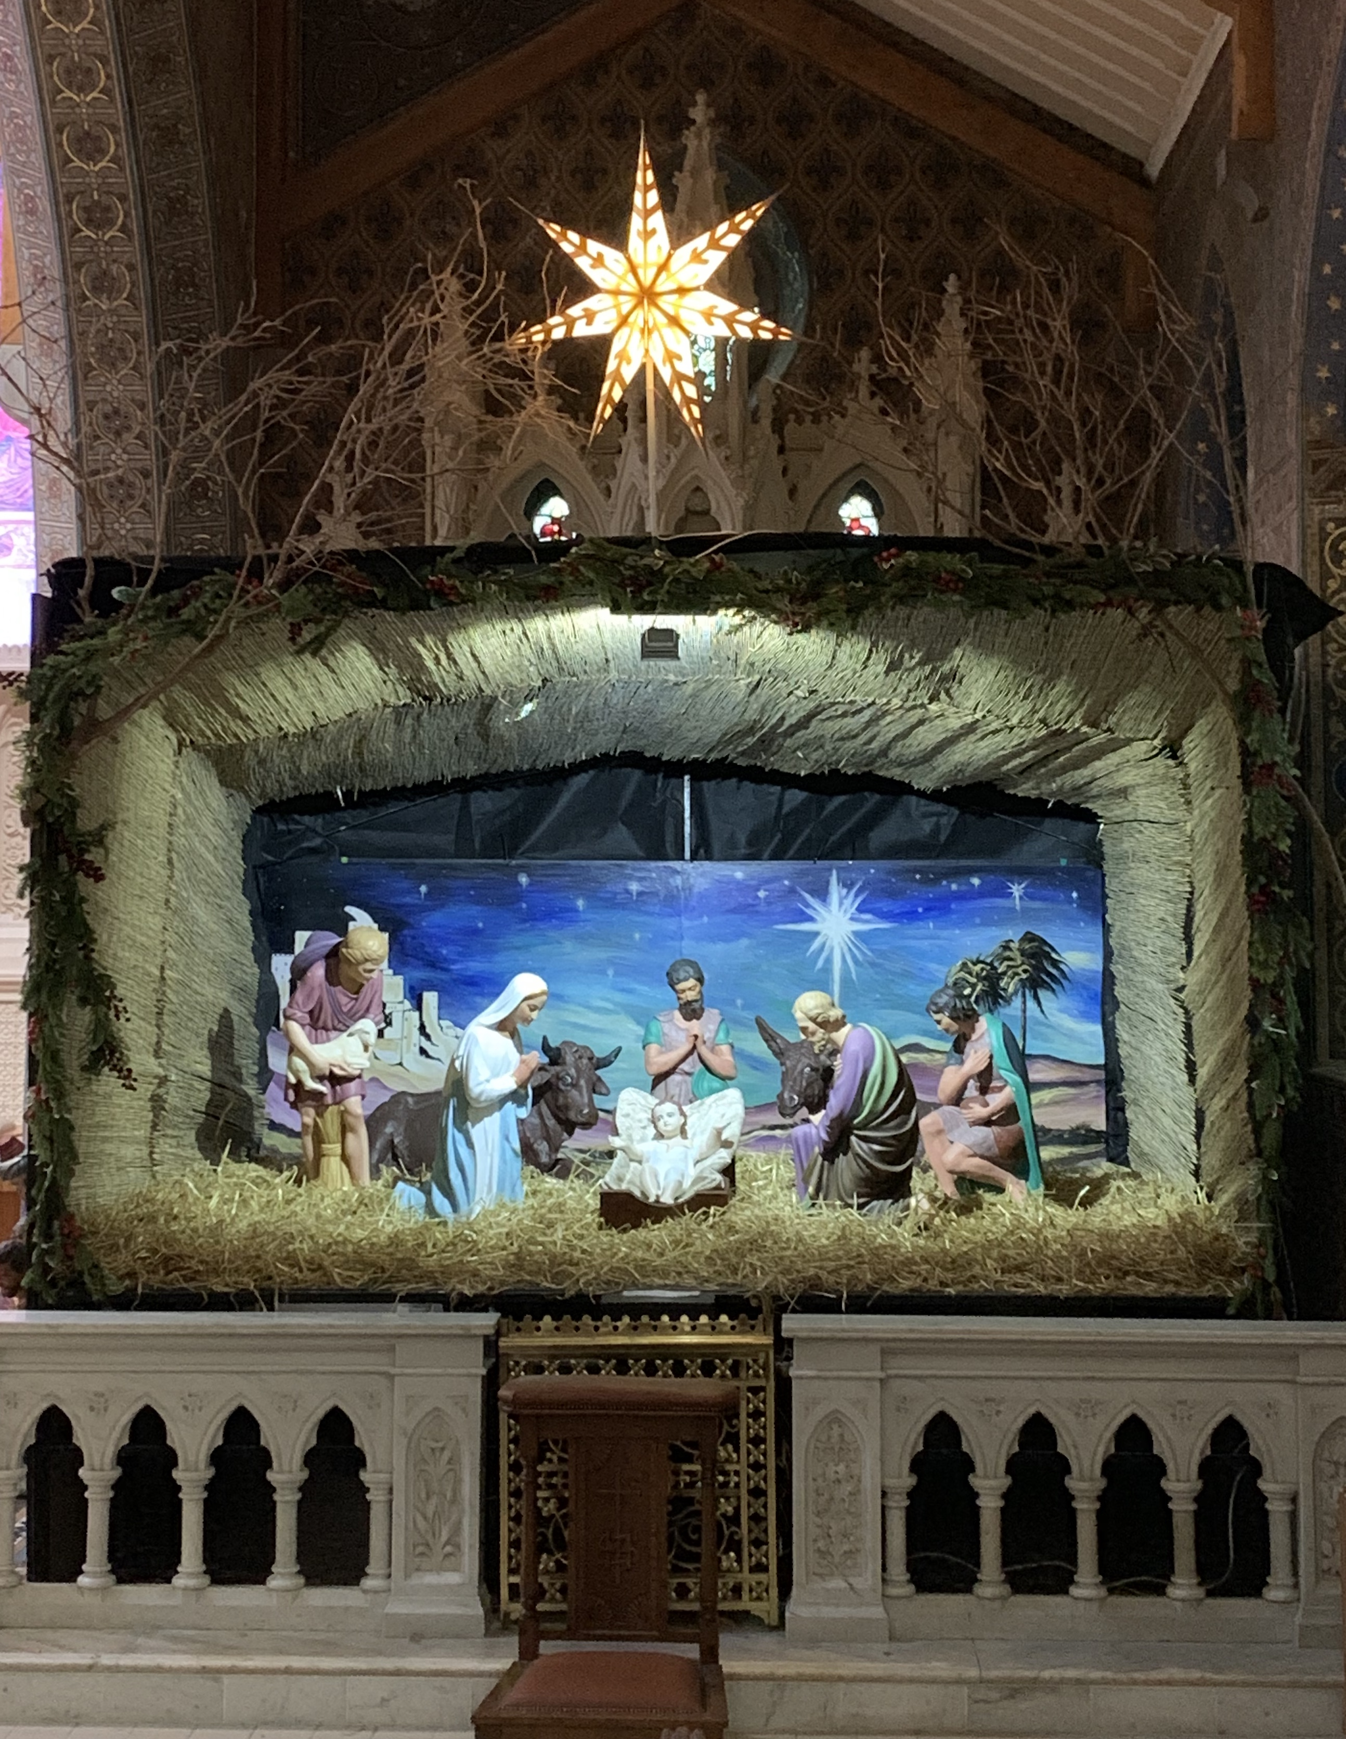

O COME LET US
ADORE HIM
JESUS CHRIST OUR LORD

