St. Mary’s Church, Listowel Holy Week PROGRAMME 2019

Listowel Parish Liturgy Group, invite you to enter into the spirit of Holy Week by joining us for the Holy Week Ceremonies which celebrate the anniversaries of the events of the Passion, Death and Resurrection of Our Lord taking place at the following times:
Palm Sunday 14th April Blessings of Palms (Vigil Mass 6.15pm. Saturday Eve & 9am. & 11.30am. on Sunday morning)

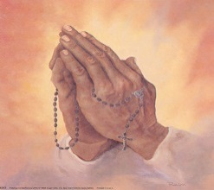
Monday 15th April Mass at 10.30 a.m.

Penitential Service at 8.00 p.m. including individual Confessions with a number of priests present.
We encourage as many as possible to avail of the opportunity to have their Easter Confession.

Tuesday 16th April Mass at 10.30 a.m. CHRISM MASS at 7.00 p.m. St. Mary’s Cathedral, Killarney.
Bishop Ray has invited all parishioners to this Mass at which the priests of the Diocese renew
their priestly vows. Also all the Oils used for the various sacraments for the coming year are blessed.
There will be refreshments after the Mass in St. Brendan’s College refectory. Everyone is welcome.

Spy Wednesday 17th April Mass at 10.30 a.m. followed by Confessions.

Holy Thursday 18th April Morning Prayer at 10.30 a.m. followed by Confessions.

Mass of the Lord’s Supper 8.00p.m. followed by Confession.
Church will remain open until 10pm. for prayer.
You are invited to spend some time with the Lord during this time.
This recalls his night of prayer in the garden of Gethsemane.

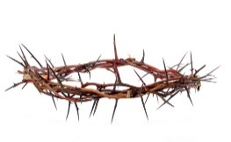
Good Friday 19th April Morning Prayer at 10.30 a.m. followed by Confession

The Lord’s Passion 3.00 p.m.

Stations of the Cross 8.00 p.m.

Holy Saturday 20th April Morning Prayer at 10.30 a.m. followed by Confessions Easter Vigil 8.00 p.m.

Easter Sunday Mass 21st APRIL 9.00 a.m. & 11.30 a.m.

